**PROJECT MANAGEMENT PLAN**

**<**Dispatch Directory System**>**

**TELUS INTERNATIONAL PHILS.**

**31/F DISCOVERY CENTRE, ADB AVENUE,**

**ORTIGAS CENTER, PASIG, 1605 METRO MANILA**

**FEBRUARY 2023**

TABLE OF CONTENTS

1. Company Profile 5

2. Business Case 6

2.1. Problem Definition 6

2.1.1. Problem Statement 6

2.1.2. Organizational Impact 6

2.1.3. Technology Migration 6

2.2. Project Overview 7

2.2.1. Project Description 7

2.2.2. Goals and Objectives 7

2.2.3. Project Performance 8

2.2.4. Project Assumptions 8

2.2.5. Project Constraints 8

2.2.6. Major Project Milestones 8

2.3. Strategic Alignment 9

2.4. Cost and Benefit Analysis 10

3. Project Charter 13

3.1. Project Purpose/Justification 13

3.1.1. Business Need 13

3.1.2. Business Objectives 13

3.2. Project Description 13

3.2.1. Project Objectives 14

3.2.2. Success Criteria **Error! Bookmark not defined.**

3.2.3. Requirements 14

3.2.4. Constraints 14

3.2.5. Assumptions 15

3.2.6. Preliminary Scope Statement 15

3.3. Risks 15

3.4. Project Key Deliverables 16

3.5. Summary Milestone Schedule 16

3.6. Budget Summary 17

3.7. Project Approval Requirements 17

4. Project Management Approach 17

5. Project Technical Approach 18

5.1. Product Development Methodology 18

5.2. Technical Architecture 18

6. Project Management Plans 19

6.1. Stakeholders Strategy Management Plan 19

6.1.1. Introduction 19

6.1.2. Identify Stakeholders 21

6.1.3. Key Stakeholders 22

6.1.4. Stakeholder Analysis 22

6.2. Scope Management Plan 25

6.2.1. Introduction 25

6.2.2. Scope Management Approach 27

6.2.3. Roles and Responsibilities 27

6.2.4. Scope Definition 28

6.2.5. Project Scope Statement 28

6.2.6. Work Breakdown Structure 30

6.2.7. Scope Verification 31

6.2.8. Scope Control 32

6.3. Cost Management Plan 33

6.3.1. Cost Management Approach 34

6.3.2. Measuring Project Costs 34

6.4. Schedule Management Plan 46

6.5. Staffing Management Plan 51

6.6. Change Management Plan

6.7. Communications Management Plan

6.8. Quality Management Plan

6.9. Risk Management Plan

6.10. Procurement Plan

6.11. Implementation Plan

7. Sponsor Acceptance

8. List of Tables

9. List of Figures

10. Appendices

10.1. Project Cost and Benefit Analysis

10.2. Project Methodology

10.3. System Requirements Specifications

10.4. Development Tools Specification

10.5. WBS Dictionary

10.6. ..... Detailed Schedule ................................................................................................................. 114

10.7. ..... Detailed Cost Estimates ........................................................................................................ 115

10.8. .....Handle Time .......................................................................................................................... 116

# 1. Company Profile

|  |  |
| --- | --- |
| **Registered Name:** | Torrecamps Marketing |
| **Company Logo:** |  |
| **Address:** | #14 San Vicente Ferrer St., SAV-1, Sucat, Parañaque City |
| **Telephone Numbers:** | 09369225861 |
| **Line of Business:** | Supplying Company |
| **Type of Customers:** | Home s customers |
| **Date of Registration:** | 2007 |
| **President:** | Jabb Torrecampo |
| **Number of Employees:** | 6 as of June 7, 2023 |

*Table 1—1: High-level Company Information*

Torrecamps Marketing is a company based in Parañaque, they are a company founded in 2017. Initially it started as a supplying company for the barangays located in Parañaque, but by April 2020 they started focusing on the “pandemic essentials” such as facemasks, alcohol, tissues, and gloves. The client's purpose is to supply the public with the necessary equipment to face the pandemic.

# 2. Business Case

### 2.1. Problem Definition

#### 2.1.1. Problem Statement

Since 2017, Torrecamps Marketing has been in business and has been selling essentials. They began selling "Pandemic Essentials" including alcohol and tissues during the pandemic. As a result, they gained more customers and stock, began working with other businesses, and expanded their selection of products. Their system remained static while their inventory and client base grew, making it challenging for them to keep up with the increase in orders that needed to be handled.

#### 2.1.2. Organizational Impact

Having this project developed by the group can have a lot of impact if it's approved. The first one is Torrecamps Marketing. The impact this system will have on Torrecamps Marketing will be that the clients can serve customers more quickly and effectively when it comes to producing printable and digital receipts for every transaction. Next is the impact of this system on the customers. In the customers’ side, the proposed system will now produce printed receipts. This is crucial since printed receipts cannot be changed.

#### 2.1.3. Technology Migration

Torrecamps Marketing currently uses desktop computers, laptops and printers for their main hardware. They also use Facebook messenger, Microsoft Excel and a 25 MBPS Converge internet provider as their main network. These tools provide a lot of things going for the client. Like facebook they post pictures with prices to advertise them. Next is customers can order their desired items using facebook messenger. And lastly there will be Microsoft Excel. Excel provides the client with a lot of things like listing customer information and listing orders. Next is printing receipts and fixing orders. Lastly there is the inventory and total sales per day.

Now that the group is tasked to create a system that helps the clients. The proposed solution of the team that will be implemented is an inventory and an ordering system. The website will be able to present the items that the client is selling. Then every order of the customer will be recorded into the inventory and the ordering system. The team will use Bootstrap studio, Visual Studio Code and XAMPP to develop the project. The website will intergrate CAMSS. The system will have a cloud-based database server. Next is tye project will have an inventory and ordering system where they can create, edit, or delete all items and information that are needed to change on the website. 3rd will be that the team plans to integrate the system in both desktop and mobile devices. The Facebook part will not be removed since it is used for their advertisement. Lastly the team will continue monitoring the website and install anti-malware software on the computer to ensure their security.

## 2.2. Project Overview

#### 2.2.1. Project Description

This Inventory System and Ordering System project is specifically designed for Torrecamps company, a business that requires a reliable and efficient inventory and ordering management system to organize their operations, reduce costs, and enhance customer service. The project will be customized to meet Torrecamps' specific business requirements and will be developed to ensure seamless integration with their existing business processes.

#### 2.2.2. Goals and Objectives

The number of clients and the volume of stock increase together with the company's growth. Torrecamps Marketing has assigned the group the duty of developing an inventory system and an ordering system for them since keeping up with the quantity of additional work that comes with growing is not a simple task. This will significantly increase the company's ability to automate its transactional and inventory processes.

#### 2.2.3. Project Performance

To ensure that the project meets Torrecamps' expectations, the following performance criteria will be used:

* + - * The system should be able to track inventory levels accurately and provide real-time updates
      * The system should generate inventory reports that are easy to understand and interpret
      * The system should have a clean and intuitive interface that is easy to navigate
      * The system should allow customers to place orders seamlessly and receive real-time inventory information
      * The system should be able to handle a large volume of orders and transactions

#### 2.2.4. Project Assumptions

The following assumptions will be considered during the project's development:

* + Torrecamps has an existing IT infrastructure that can support the new system
  + Torrecamps' staff members are adequately trained to use the new system
  + The project team has access to all the necessary data and resources required to develop the system

#### 2.2.5. Project Constraints

The following constraints will be considered during the project's development:

* + The project will be constrained by Torrecamps' budget and timeline
  + The project will be developed to work within Torrecamps' existing business processes and constraints

#### 2.2.6. Major Project Milestones

|  |  |
| --- | --- |
| PROJECT START | 08/15/2022 |
| PLANNING | 08/15/2022 - 11/09/2022 |
| ANALYSIS AND DESIGN | 11/26/2022 - 03/08/2023 |
| CODING | 03/23/2023 - PRESENT |
| BETA TESTING | 2023 |
| PROJECT COMPLETE | 2023 |

## 2.3. Strategic Alignment

Torrecamps Marketing is currently looking to grow their business in terms of their inventory to keep up with their already growing customer base. The system that they currently have in place has multiple flaws that leads to them needing time to compensate and cover for their mistakes, this is where the group’s project comes in as it automates their transactional tasks and inventory tasks giving them more time and manpower to focus on other tasks that they need to be focusing on in order to improve their company.

## 2.4. Cost and Benefit Analysis

A cost-benefit analysis (CBA) is a systematic approach to assessing the advantages and disadvantages of a proposed project or system. In the case of an inventory and ordering system, the CBA would evaluate the costs associated with implementing and maintaining the system against the potential benefits it offers. Here are some key factors to consider:

**Benefits:**

Below are the identified benefits that the project can bring once fully implemented:

* Time Savings: Determine the extent to which the system streamlines inventory management and ordering processes, reducing the time required for manual tasks and administrative work.
* Inventory Optimization: Assess the potential for improved inventory control, reduced stockouts, and minimized holding costs by optimizing ordering quantities and frequencies based on real-time data.
* Cost Reduction: Identify potential savings through more accurate demand forecasting, reduced overstocking, and better supplier management, leading to lower carrying costs and improved cash flow.
* Enhanced Accuracy: Consider the reduction in errors and inaccuracies that may result from automating inventory tracking and order processing, leading to improved customer satisfaction and reduced costs associated with order errors.
* Reporting and Analytics: Evaluate the system's capability to generate valuable reports and analytics, enabling data-driven decision-making for inventory management, identifying trends, and optimizing ordering strategies.

**Costs:**

* + - Initial Investment: Determine the upfront costs of acquiring the system, including hardware, software licenses, and implementation expenses.
    - Training and Integration: Consider the costs of training employees on how to use the system effectively. Integration with existing systems or processes may also require additional expenses.
    - Maintenance and Support: Evaluate the ongoing costs for system updates, bug fixes, and technical support.
    - Infrastructure: Assess any infrastructure upgrades or modifications needed to support the system, such as networking or server requirements. e. Operational Costs: Account for ongoing expenses related to system operations, such as electricity, internet connectivity, and staff required to manage and maintain the system.

As a quick overview, the contract between TELUS and the CREST client indicates that other direct costs such as work equipment, electricity, and internet; and indirect costs such as subscriptions to services are already included in the package that the client has signed up for. Therefore, any direct and indirect costs accumulated for any given project within the account are already anticipated for and included in the annual budget allocated for the program.

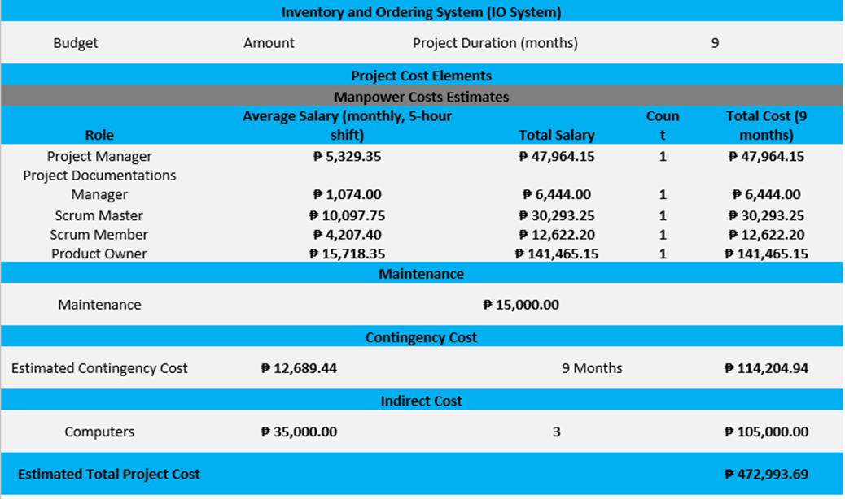

*Figure 2.4—1: Estimated Costs*

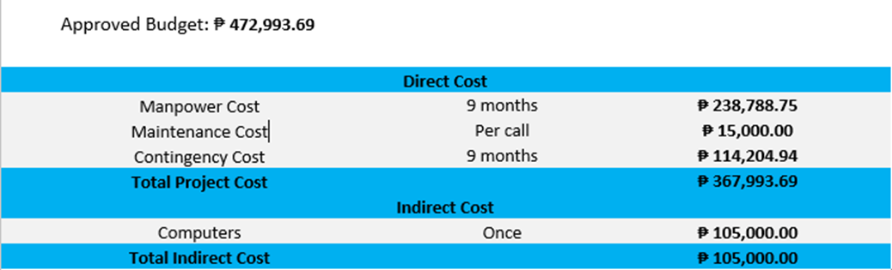

*Figure*

*2.4—2: Cost Benefit Analysis*

According to table 2, the project's budget is PHP 472,993.68 and its anticipated completion date is in 9 months. The project elements are as follows:

* + - * Manpower Costs
      * Maintenance Cost
      * Contingency Cost

An estimated PHP 40,888.00 per month was spent on the project. If we were to split down the aforementioned sum, 98% (PHP 36,799) would go for the workers and the remaining portion would go toward the contingency reserve. The contingency fund will roll over to the following month if it is not used for the current month, and so on. The whole expected cost of the project will be deducted from the accumulated unused contingency fund at the conclusion of the project, and this amount will be included in the estimated savings.

The cost of maintenance would also be included in the estimate, and it is essential to make sure the system continues to operate optimally and successfully even after the project is finished.

In conclusion, it is anticipated that the Inventory and Ordering System will offer significant advantages that offset the expenses paid. To make sure that the advantages are being realized and that the project is on track, the project team should regularly monitor and analyze the project.

# 3. Project Charter

## 3.1. Project Purpose/Justification

#### 3.1.1. Business Need

Torrecamps Company needs to adapt to technological demands to fulfill the customer’s needs to remain competitive in the market. Furthermore, the organization must strengthen its marketing efforts and internet presence since the company is slowly emerging and attracting a larger audience.

#### 3.1.2. Business Objectives

These business goals can assist Torrecamps Company in reaching its goal of being the leading supplier of basic commodities. All these goals are SMART since they are specific, measurable, attainable, relevant, and time bound.

* Increase online sales revenue by 60% within the next 12 months by implementing the system.
* Improve customer satisfaction ratings by 80% within the next 9 months by implementing a streamlined workflow.
* For Torrecamps company to reduce errors or any discrepancies by 85-90% in their transactions by having an ordering system and inventory system.

## 3.2. Project Description

This Inventory System and Ordering System project is specifically designed for Torrecamps company, a business that requires a reliable and efficient inventory and ordering management system to organize their operations, reduce costs, and enhance customer service. The project will be customized to meet Torrecamps specific business requirements and will be developed to ensure seamless integration with their existing business processes.

#### 3.2.1. Project Objectives and Success Criteria

**Main Objective**

To create a web-based inventory and ordering system for Torrecamps Marketing Company so that inventory ___ are accurate and order transactions are error-free.

**Specific Objectives**

* To provide real-time generated reports regarding the inventory and ordering transactions online.
* To accurately record the information of the customers, including their transactions made online.

#### 3.2.3. Requirements

This project must meet the following list of requirements to achieve success.

* The system must pass the beta testing before proceeding to implementation.
* Torrecamps Company must 100% completely understand and interpret the system so that it is easy to navigate.

Additional requirements may be added as necessary, with project sponsor approval, as the project moves forward.

#### 3.2.4. Constraints

The following constraints will be considered during the project's development:

* + The project will be constrained by Torrecamps' budget and timeline.
  + The project will be developed to work within Torrecamps' existing business processes and constraints.

#### 3.2.5. Assumptions

The following assumptions will be considered during the project's development:

* + Torrecamps has an existing IT infrastructure that can support the new system.
  + Torrecamps staff members knows how to interact with webapps.
  + The project team has access to all the necessary data and resources required to develop the system.

#### 3.2.6. Preliminary Scope Statement

The group will develop an inventory system and ordering system for Torrecamps Marketing. This will automate their transaction process and allows the users to order within the system which brings more flexibility and efficiency and eliminates the inconvenience from their previous transaction process and inventory needs. Delivering operational improvements, minimizing customer service issues for better service. It also includes Invoice, Transaction report, Printing receipts and Inventory management, List of Orders which allows for viewing and adding of stocks, viewing of orders, contact supplier. This project will help Torrecamps to have more control over their business, providing the client's needs for the improvement of their business.

## 3.3. Risks

The following risks for the Inventory and Ordering system have been identified by the developers. The project manager will use proper risk mitigation to minimize the possible of these risks:

* Potential disruption to operations due to power outage
* External threats breaching in the database.
* Data theft due to internet security breach.

## 3.4. Project Key Deliverables

The following deliverables must be met upon the successful completion of the Inventory system and Ordering system project. Any changes to these deliverables must be approved by the project sponsor.

* Inventory Management System: A web-based system that tracks inventory levels and helps manage stock movements, including purchases, sales, and returns.
* Ordering System: A web-based system that allows customers to place orders for essential items like face masks, alcohol, and other health-related products.
* User Documentation: Detailed instructions on how to use the ordering system as well as the inventory management system.
* Training Resources: Resources for teaching staff members how to utilize the new systems efficiently.

## 3.5. Summary Milestone Schedule

The project summary milestone schedule is presented below. The Project Sponsor must approve any schedule changes which may impact milestones in coordination with the Project Manager. A detailed schedule will be included in the project plan.

|  |  |
| --- | --- |
| **Summary Milestone Schedule – List key project milestones relative to project start.** | |
| **Project Milestone** | **Target Date (mm/dd/yyyy)** |
| 1. Planning | 08/15/2022 - 11/09/2022 |
| 1. Analysis and Design | 11/26/2022 - 03/8/2023 |
| 1. Coding | 03/23/2023 - Present |
| 1. Beta Testing | 2023 |
| 1. Project Complete | 2023 |

## 3.6. Budget Summary

The following table contains a summary budget based on the planned cost components and estimated costs required for successful completion of the project. The total budget for the project is ₱406,388 the breakdown is in the table below:

|  |  |
| --- | --- |
|  | Price |
| Hardware and Software Costs | ₱45,000 |
| Server hardware and software | ₱4,000 |
| Client hardware and software | ₱35,000 |
| Database software and licenses | ₱10,000 |
| Network infrastructure | ₱1,699.00 (per month) – ₱20,388 (per annum) |
| Implementation and Integration Costs | ₱150,000 |
| System design and development | ₱80,000 |
| Testing and quality assurance | ₱10,000 |
| Data migration | ₱10,000 |
| System integration | ₱40,000 |
| Training and Support Costs | ₱10,000 |
| Ongoing support and maintenance | ₱2,000 (per appearance) |
| Total Project Budget | ₱406,388 |

## 3.7. Project Approval Requirements

The completion of the Inventory System and Ordering System project for Torrecamps Company will be authorized solely by the project client, Torrecamps Company. The project will only be considered complete when Torrecamps Company approves the system's functionality and determines that it meets the project goals and objectives. Any changes or modifications to the project scope or timeline must also be approved by Torrecamps Company and the Project Manager.

# 4. Project Management Approach

Stefano Franco Binay is the Project Manager that handles the project for Torrecamps Marketing Company. He is responsible for the cost, project plan, delegates responsibilities, and scheduling meetings with their project adviser Ms. Roselle Gardon, and ensures the successful and timely completion of the project. Mr. Binay is hereby authorized to approve any changes regarding the documentation and prototype. As the Project Manager, he maintains control of the changes and keeps the client updated as well as their Project Adviser.

# 5. Project Technical Approach

For the Dispatch Directory System project, our technical approach is based on a thorough analysis of the project requirements and constraints. Our team will follow a structured and agile product development methodology that is designed to ensure timely delivery of a highquality product that meets the client's expectations.

## 5.1. Product Development Methodology

Our product management approach is a hybrid of agile and traditional project management frameworks. We will utilize agile methods such as Scrum to allow for quick iterations and continuous feedback from stakeholders. At the same time, we will employ traditional project management methods such as Waterfall to ensure that the project is delivered on time and within budget.

The methodology includes the following steps:

* Project Initiation
* Planning
* Execution
* Monitoring and Controlling
* Closure

Throughout the product development life cycle, we will engage in continuous communication with the client to ensure that the project is on track and meets their needs. We will also prioritize user experience and design to ensure that the product is intuitive and user-friendly.

## 5.2. Technical Architecture

The Dispatch Directory System will be built using a modern, cloud-based technical architecture that is designed for scalability, security, and performance. Our team will utilize microservices architecture to allow for modular and flexible development.

The system will be hosted on a secure and reliable cloud platform, ensuring that it is accessible from anywhere in the world. We will also use best-in-class security measures to protect the system from cyber threats and unauthorized access.

The user interface will be built using modern front-end technologies such as React and

Angular, providing a responsive and intuitive experience for users. We will also leverage a variety of back-end technologies, including Node.js, Java, and Python, to provide a robust and reliable system. Our team will also use automated testing and continuous integration and deployment (CI/CD) processes to ensure that the system is always up-to-date and functioning optimally.

The technical architecture of the Dispatch Directory System project is designed to ensure that the application is efficient, reliable, and secure. The architecture is based on a client-server model, where the client is a web browser, and the server is the application server.

The server-side of the application will be developed using Java Enterprise Edition (JEE) and will run on an Apache Tomcat web server. The application will use a three-tier architecture, separating the presentation, application, and data layers.

The presentation layer will consist of HTML, CSS, and JavaScript, which will be used to create the user interface. The application layer will include Java Servlets and Java Server Pages (JSPs), which will handle the business logic of the application. The data layer will be based on a relational database management system (RDBMS), such as MySQL or Oracle, which will store and manage the application data.

To ensure the security of the application, the technical architecture will include a number of security measures. These will include user authentication and authorization, data encryption, secure data transmission, and secure coding practices.

In addition, the technical architecture will be designed to be scalable, so that it can accommodate future growth and expansion. This will be achieved using load balancers, clustering, and other scalability techniques. Overall, the technical architecture of the Dispatch Directory System project will ensure that the application is robust, secure, and scalable, and will provide a solid foundation for the successful delivery of the project.

# 6. Project Management Plans

## 6.1. Stakeholders Strategy Management Plan

#### 6.1.1. Introduction

The goal of the stakeholder management strategy for the project is to effectively engage and manage the expectations of all stakeholders throughout the project life cycle. This includes identifying and analyzing stakeholder needs and interests, developing a communication plan to keep stakeholders informed and engaged, and managing stakeholder expectations to ensure that the project delivers value and meets the needs of all stakeholders.

In addition, this stakeholder management plan for a Dispatch Directory System will ensure that the needs and expectations of all stakeholders are considered and balanced in the design and operation of the system. This includes ensuring that the system is effective and efficient in meeting the needs of its users, as well as being responsive to the concerns and feedback of stakeholders such as employees, customers, and community members.

The objectives of this strategy are to:

* Identify all key stakeholders and their level of interest in the project
* Analyze the needs and expectations of each stakeholder group
* Develop a communication plan to keep stakeholders informed and engaged throughout the project
* Identify and manage potential conflicts or competing objectives among stakeholders
* Ensure that the project delivers value and meets the needs of all stakeholders
* Establish a system for ongoing stakeholder engagement and feedback to monitor and evaluate the effectiveness of the stakeholder management plan and ensure that the project remains aligned with stakeholder needs and expectations.
* Involving the stakeholders in the planning and decision–making process to help ensure that the concerns of the stakeholders are all considered.

Some potential strategies for a Dispatch Directory System to have better stakeholder management could include:

* **Improving communication and transparency:** It can help improve communication between different stakeholders, such as dispatchers, drivers, and customers, by providing a centralized platform for information sharing. This can help reduce misunderstandings and improve trust between stakeholders.
* **Increasing efficiency:** Currently, it takes an average of 9 minutes for a tenured team member to process a dispatch request.The Dispatch Directory System can streamline processes and reduce the time and resources required to complete tasks, such as assigning and tracking deliveries. This can help improve the overall efficiency of the dispatch process and increase customer satisfaction.
* **Enhancing customer service**: A dispatch directory system can provide customers with real-time updates on the status of their orders and delivery, helping to improve the overall customer experience.
* **Reducing costs:** By automating and streamlining certain tasks, a dispatch directory system can help reduce the cost of operation and increase profitability.
* **Enhancing data analytics and decision-making:** The Dispatch Directory System can provide valuable data and insights that can help managers make better informed decisions about resource allocation, routes, and other key factors.

#### 6.1.2. Identify Stakeholders

The goal of the Stakeholder Management Strategy for the dispatch project is to ensure that all stakeholders are identified, their interests and influence on the project are understood, and their needs and expectations are effectively managed. In other words, the aim of the stakeholder management strategy for the dispatch directory system is to identify and engage with all individuals or groups that have a personal stake in the project and will be impacted by its implementation or success. To achieve this, the project team will follow a structured methodology to identify stakeholders. This will involve conducting interviews with key personnel, reviewing relevant documents and data sources, and engaging with various stakeholders through focus groups and other consultation processes.

To identify its stakeholders, a structured method can be used which involves:

* Identifying all potential stakeholders through a stakeholder analysis. This includes identifying internal stakeholders (such as employees and management) and external stakeholders (such as customers, suppliers, and regulatory bodies).
* Prioritizing stakeholders based on their level of influence, power, and impact on the project. This will help determine how much time and resources should be allocated towards engaging with each stakeholder.
* Developing a stakeholder engagement plan to outline how each stakeholder will be engaged and communicated with throughout the project.
* Maintaining ongoing communication with stakeholders to ensure that their needs and concerns are addressed and that the project stays on track.

Stakeholders will be defined as any individuals or groups who have an interest in or are impacted by the project, such as employees, customers (Technicians and Managers), Management team, and/or other organizational team members. The project team will use a stakeholder analysis tool to categorize stakeholders based on their level of interest and influence and will develop tailored communication and engagement plans for each stakeholder group. This will help to ensure that all stakeholders are kept informed about the project's progress and are able to provide input and feedback as needed. By effectively managing stakeholders, the project team can build support for the project, address any concerns or issues that may arise, and increase the chances of project success.

#### 6.1.3. Key Stakeholders

The key stakeholders in this dispatch directory system project are TELUS Technicians, TELUS Managers, and CREST (Cable Repair Escalations Support Team) Team Members. These individuals will be directly impacted by the project as they are the primary users of the system. As such, it is important to ensure that their needs and concerns are properly addressed during the development of the system.

In addition, the project sponsor and project manager have also been identified as key stakeholders as they will be responsible for ensuring the successful delivery of the project. It is essential to involve these stakeholders in the decision-making process and ensure that their input is taken into consideration throughout the project.

|  |  |  |  |  |
| --- | --- | --- | --- | --- |
| **Name** | **Position** | **Internal, External** | **Project Role** | **Contact Information** |
| Mir Tolentino | Manager of Operations | Internal | Project Sponsor | mir.tolentino@telusinternationa  l.com |
| CREST Team | Team  Members of  Operations | Internal | Internal User of the system | CREST@telus.com |
| TELUS Technicians | Technicians, Customers | External | External user of the system | Cablerepair@telus.com |
| TELUS Managers | Managers, Customers | External | External user of the system | cnoemanagers@telus.com |
| Roselyn Angeles | Consultant | External | Project  Manager | roselyn.angeles@telusinternatio nal.com |

*Table 6.1—1: Stakeholder Register/Profile*

#### 6.1.4. Stakeholder Analysis

Conducting a stakeholder analysis is a crucial element of the stakeholder management plan for the dispatch directory system. It involves identifying and evaluating all individuals or groups that have a vested interest in the project and will be impacted by its implementation or success. By conducting a stakeholder analysis, the project team can determine who the key stakeholders are, their level of influence and power, and their potential impact on the project. This information is crucial for developing an effective stakeholder management strategy, as it helps the project team to prioritize the stakeholders and determine how best to engage and communicate with them throughout the project. The table below outlines the stakeholders for the project, indicating those who have a high or low level of interest and power in the development process.

|  |  |  |  |
| --- | --- | --- | --- |
| **Name** | **Power/ Interest** | **Current**    **Engagement** | **Potential Management Strategies** |
| Mir Tolentino | High/High | Neutral | Mir is very approachable and likes to be informed / updated via email, video calls and in person. Manage closely and collaborate with her to keep her fully engaged with the project's progress. |
| CREST | Low/High | Supportive | Team Members of CREST are resilient and very productive. They are very much supportive of changes within their organization that could provide potential growth and success to their team. They need to be aware of the changes and to let them know that the change is in everyone's best interest. They can offer great insights and ideas for the project. |
| TELUS Technicians | Low/Low | Neutral | They are one of the customers of CREST Team and are assigned on field in Canada. Monitor them as they will most likely require some communication regarding the project's development. |
| TELUS Managers | High/Low | Leading | They manage TELUS field technicians in Canada, and they are one of the customers of CREST Team. They can be considered context-setters as they can have a lot of influence in the company and over the project but will not let themselves be involved in the project details. There's a need to keep them satisfied/ up to date with the project's progress but do not over-communicate with them as this might lead to a total loss of interest. |
| Roselyn Angeles | Low/High | Supportive | She is the project manager who oversees the progress of the project. She gets along with everybody in the project team and is professional. Keep her informed of the deliverables' completions and delays, issues, changes, and other projectrelated concerns. |

*Table 6.1—2: Stakeholder Analysis*

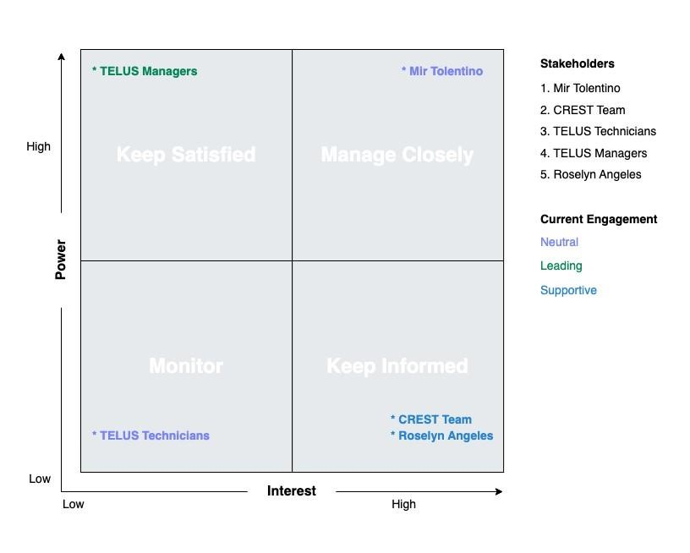

*Figure 6.1—1: Stakeholder Analysis*

## 6.2. Scope Management Plan

#### 6.2.1. Introduction

The scope management plan for the Dispatch Directory System outlines the best practices and cutting-edge tools that will be used to define, document, and control the scope of the project. By leveraging agile methodologies and real-time collaboration tools, the project team will be able to deliver an innovative dispatch directory system that meets the needs of all stakeholders.

**Scope Definition:** The scope of the Dispatch Directory System will be defined through the following activities:

1. **Requirements gathering:** The project team will use a variety of techniques to gather and document the requirements for the system, including users' interviews, focus group discussions, and online surveys.
2. **User stories:** The project team will create user stories to describe the functionality of the system from the perspective of the end user. These stories will be prioritized based on business value and will be used to guide the development process.

1. **Scope statement:** The scope statement will be created using the user stories and requirements as input. It will provide a high-level overview of the project scope, including the deliverables, exclusions, and constraints.

1. **Scope baseline:** The scope baseline will be created by incorporating the scope statement and the user stories into a project management plan. It will be regularly updated as the project progresses to reflect changes in scope.

**Scope Documentation:** The scope of the Dispatch Directory System will be documented in the following ways:

1. **Requirements documentation:** The requirements for the system will be documented in a requirements specification document.

1. **Project management plan:** The project management plan will include the scope statement, the scope baseline, and any other relevant information about the scope of the project.

1. **Change log:** A change log will be maintained to track all changes to the scope of the project, including the description of the change, the impact on the project, and the required approvals.

**Scope Control:** The scope of the Dispatch Directory System will be controlled through the following activities:

1. **Scope verification:** The project team will use agile testing techniques to verify that the deliverables of the project meet the requirements and align with the scope statement.

1. **Scope change control:** Any changes to the scope of the project will be managed through a formal change control process, which will include an assessment of the impact on the project schedule, budget, and quality.

1. **Scope change review:** A scope change review will be held for each change request to ensure that the change is necessary, feasible, and aligned with the project objectives.

#### 6.2.2. Scope Management Approach

1. Authority and responsibility for scope management will be held by the Project Manager, Roselyn Angeles, who will work closely with the project sponsor, Mir

Tolentino, and other key stakeholders to define and manage the scope of the project.

1. The scope of the project will be defined through the creation of a Scope Statement, Work Breakdown Structure (WBS), and WBS Dictionary, as well as a detailed Statement of Work (SOW). These documents will clearly outline the project deliverables, tasks, and requirements, and will be reviewed and approved by the project sponsor and other stakeholders before work begins.

1. The scope of the project will be measured and verified with quality checklists, work performance measurements, and regular review of the project's progress against the scope baseline. Any deviations from the scope baseline will be identified and addressed through the scope change process.

1. The scope change process for the Dispatch Directory System project will involve the submission of a scope change request by the Project Manager, with final approval being granted by the project sponsor. Any changes to the scope of the project must be carefully evaluated to ensure that they align with the project's goals and objectives, and do not negatively impact the project schedule or budget.

1. The final project deliverables will be accepted and approved by the project sponsor and other key stakeholders, with the Project Manager being responsible for ensuring that all project requirements have been met. The successful completion of the project will be confirmed once all deliverables have been accepted and any outstanding issues have been resolved.

#### 6.2.3. Roles and Responsibilities

The following roles and responsibilities have been assigned in relation to scope management:

* **Project manager:** The project manager is responsible for defining and documenting the scope of the project, as well as controlling and approving scope changes.
* **Product owner:** The product owner is responsible for representing the needs and priorities of the stakeholders, and for ensuring that the project delivers value to the business.
* **Project team:** The project team is responsible for verifying the scope of the project, and for raising change requests if necessary.
* **Stakeholders:** Stakeholders are responsible for providing input on the requirements and scope of the project, and for approving scope changes as needed.

#### 6.2.4. Scope Definition

The scope of this project includes the development of a single system that combines the functionality of the three dispatch tools currently used by the Cable Repair Escalations Support Team (CREST). This system will include features such as a COID directory to identify the correct location of TELUS facilities, a viewing module to retrieve relevant information about a COID, and a schedule module to show the availability of TELUS managers.

The system will also include improved tracking processes to enhance the efficiency and effectiveness of the CREST team.

#### 6.2.5. Project Scope Statement

The project scope statement for the dispatch directory system project will detail the project's deliverables and the work necessary to create these deliverables.

**Product Scope Description:**

The Dispatch directory system will be a web-based tool that allows dispatchers to plan and schedule technicians' activities, such as service calls, site visits, and other tasks. It will also allow dispatchers to track the progress and accomplishments of technicians, as well as monitor the performance of the teams and individuals they oversee.

This system will include features such as a calendar and task management tools, as well as reporting and analysis capabilities to help managers track their performance and the performance of their teams.

**Product Acceptance Criteria:**

The Dispatch Directory System will be considered complete and accepted by the customer when it meets the following criteria:

* All features and functionalities specified in the project scope statement have been developed and tested using the test cases created by the Quality Assurance Associate.
* The system has been successfully deployed within the TELUS’ VDI environment.
* The system has received positive feedback from users during UTA.
* The system has been thoroughly documented and user manuals have been created.

**Project Deliverables:**

The following list of deliverables will be provided upon successful completion of the project:

* + Inventory Management System: A web-based system that tracks inventory levels and helps manage stock movements, including purchases, sales, and returns.
  + Ordering System: A web-based system that allows customers to place orders for essential items like face masks, alcohol, and other health-related products.
  + User Documentation: Detailed instructions on how to use the ordering system as well as the inventory management system.
  + Training Resources: Resources for teaching staff members how to utilize the new systems efficiently.

**Project Exclusions:**

The following work is outside the scope of this project and will not be included:

* Integration of other systems or software not specifically mentioned in the project scope statement
* Customization or modification of the system beyond the scope specified in the project scope statement

**Project Constraints:**

The following constraints will be considered during the project's development:

* + The project will be constrained by Torrecamps' budget and timeline.
  + The project will be developed to work within Torrecamps' existing business processes and constraints.

**Project Assumptions:**

The following assumptions will be considered during the project's development:

* + Torrecamps has an existing IT infrastructure that can support the new system.
  + Torrecamps staff members knows how to interact with webapps.
  + The project team has access to all the necessary data and resources required to develop the system.

#### 6.2.6. Work Breakdown Structure

Work breakdown structure is a tool in project management to divide larges projects to get things done faster and efficiently. The WBS structure gives a clear knowledge of the project scope, deliverables, and activities at each level, representing an increasingly precise description of the project work. The work breakdown structure (WBS) acts as a roadmap for project managers to plan, execute, and monitor project activities, and it helps to guarantee that all project requirements are satisfied within the time and budget constraints.

The Work Breakdown Structure presented here represents all the work required to complete this project.

# Outline View

The outline view presents an easy to view and understand layout for the Ordering system and Inventory system.

1. Ordering System and Inventory System
   1. Project Planning
      1. Define project scope and objectives
      2. Identify project stakeholders
      3. Develop project schedule
      4. Define project budget
      5. Establish project team roles and responsibilities
   2. Requirements Gathering
      1. Define system requirements
      2. Identify inventory system requirements
      3. Identify ordering system requirements
      4. Define user requirements
      5. Conduct stakeholder interviews
   3. System Design
      1. Design ordering system
      2. Design inventory system
      3. Define user interface design
      4. Determine software and hardware requirements
      5. Develop system architecture
   4. System Development
      1. Code ordering system
      2. Code inventory system
      3. Integrate system components
      4. Develop test plans
      5. Conduct testing
   5. System Implementation
      1. Deploy system in test environment
      2. Train system users
      3. Resolve any issues found during testing
      4. Deploy system in production environment
      5. Perform system maintenance and support
   6. Project Management
      1. Monitor and control project progress
      2. Manage project risk and issues
      3. Communicate project status to stakeholders
      4. Ensure project deliverables meet quality standards
      5. Obtain project acceptance from stakeholders

#### 6.2.7. Scope Verification

To ensure that the deliverables from the Dispatch Directory System project meet the original scope, the project team will utilize a variety of methods for scope verification. These methods may include:

* **Quality checklists:** These lists will outline the specific requirements that each deliverable is met in order to be accepted. The project team will use these checklists to verify that each deliverable meets all necessary criteria before moving forward.
* **Work performance measurements:** The project team will track and measure the progress of each deliverable as it is being developed. This will allow the team to identify any potential issues or deviations from the original scope and address them in a timely manner.
* **Scope baseline:** The project team will maintain a scope baseline, which is a snapshot of the original project scope. Any changes to the scope must be documented and approved before they are implemented. The scope baseline will be used to ensure that the final deliverables meet the original scope.
* **Formal acceptance:** The project sponsor, customer, and other stakeholders will formally accept each delivery as it is completed. This ensures that the project team is meeting the expectations of all relevant parties — allowing any necessary feedback or changes to be made in a timely manner.

Overall, it is important that the project team maintains consistent communication and collaboration with the customer and other stakeholders throughout the project in order to ensure that the deliverables meet the original scope and are formally accepted.

#### 6.2.8. Scope Control

The scope control process for the project will involve regular reviews of the project's deliverables and progress to ensure that they align with the original project scope as defined in the Project Scope Statement. Any deviations from the scope will be evaluated and, if necessary, changes to the scope will be documented and approved through the established scope change process. The Project Manager will be responsible for monitoring and controlling the project's scope, with assistance from the project team and stakeholders. Periodic reviews of the project's scope will be conducted to ensure that the project remains on track and within the defined boundaries. The project manager will also be responsible for ensuring that any scope changes are properly documented and that all impacted parties are notified of any changes.

The scope control process for the Dispatch Directory System project will involve the following steps for making changes to the scope baseline:

* A scope change request will be initiated by any stakeholder or team member who identifies a need for a change to the scope.
* The scope change request will be reviewed by the Project manager and the Project Sponsor to assess the impact of the change on the project schedule, budget, and resources.
* If the change is deemed low impact, the Project Manager can approve or deny the request. If the change is deemed high impact, the Project manager can approve

or deny the request. Any low impact change request approved or denied by the Project Manager can be reviewed and overruled by the Project Sponsor.

* If the request is approved, the Project Manager will create an action plan to proceed with the change and update the scope baseline and notify all relevant stakeholders of the change.
* If the request is rejected, the project team will continue with the original scope.

It is important to have a formalized process for making changes to the scope baseline in order to ensure that the project stays on track and within budget. Any changes to the scope should be carefully assessed and approved in order to avoid scope creeps and keep the project on track.

## 6.3. Cost Management Plan

The Cost Management Plan for the Dispatch Directory System project is designed to ensure that all costs associated with the project are effectively managed throughout its lifecycle. The plan outlines the format and standards by which the project costs will be measured, reported, and controlled.

**Cost management responsibilities:**

* The Project Manager will be responsible for overall cost management of the project and will be the primary point of contact for all cost-related issues.
* The Finance Team will be responsible for monitoring project costs and ensuring that they are within the approved budget.

**Cost change approval:**

* All cost changes must be approved by the Project Manager before they are implemented.
* If the cost change exceeds 10% of the total project budget, it must be approved by the Project Sponsor before it can be implemented.

**Cost measurement and reporting:**

* Costs will be measured and reported on a monthly basis, using a cost performance index (CPI) and a schedule performance index (SPI)
* Reports will be presented to the Project Sponsor on a monthly basis.

**Budget format and standards:**

* The budget will be presented in a clear and concise format, using a spreadsheet format such as Excel.
* The budget will be broken down into individual line items, with detailed cost estimates for each item.
* The budget will be updated on a monthly basis, with any changes clearly highlighted.

Overall, the Cost Management Plan for the Dispatch Directory System project is designed to ensure that all costs associated with the project are effectively managed and controlled, so that the project can be completed within the approved budget. This will help ensure that the project is completed successfully and on time.

#### 6.3.1. Cost Management Approach

The cost management approach for the dispatch directory system project will be based on the following principles:

* **Clear definition of costs**: The project team will work closely with stakeholders to clearly define and document the costs associated with the project, including labor, materials, equipment, and other expenses.
* **Budget development and tracking:** A detailed project budget will be developed and regularly updated throughout the project, with costs tracked and reported in real time.
* **Cost estimates:** The project team will use a variety of cost estimation techniques to ensure that the project budget is accurate and realistic.
* **Cost variance analysis:** The project team will closely monitor costs throughout the project and perform variance analysis to identify and address any cost overruns or savings.
* **Cost management roles and responsibilities:** Clear roles and responsibilities for cost management will be defined and communicated to all project team members.
* **Approval process for changes:** A formal process for approving changes to the project or its budget will be established and implemented.
* **Reporting and communication:** Regular cost reports will be prepared and shared with stakeholders, including the project sponsor, project team, and management.

By following these principles and practices, the project team will be able to effectively manage costs and ensure that the project stays on budget.

#### 6.3.2. Measuring Project Costs

The Cost Management Plan for the Dispatch Directory System project will include a detailed approach for measuring project costs using Earned Value Management (EVM). This will involve capturing and reporting on various Earned Value metrics, such as:

1. Budgeted Cost of Work Scheduled (BCWS) or Planned Value (PV) - This measures the budgeted costs of the work that was planned to be completed at a specific point in time.

**Example**:

To calculate the BCWS or Planned Value, we need to multiply the total labor cost of the TESTING WBS by its percentage of completion:

BCWS = Total labor cost of TESTING WBS x Percentage of completion

= (PHP 300,000) x 33.71%

= PHP 101,130

Therefore, the Budgeted Cost of Work Scheduled (BCWS) or Planned Value (PV) for the TESTING WBS is **PHP 101,130.**

1. Budgeted Cost of Work Performed (BCWP) or Earned Value (EV) - This measures the budgeted costs of the work that has been completed at a specific point in time.

**Example**:

To calculate the Budgeted Cost of Work Performed (BCWP) or Earned Value (EV), we need to know the percentage of work completed for each task or WBS element. Assuming that the percentage of completion for each of the Testing Phase tasks are as follows:

Week 26: Testing Phase 1 - 100%

Week 27: Testing Phase 2 - 75%

Week 28: Testing Phase 3 - 50%

Week 29: Testing Phase 4 - 25%

Then, we can calculate the Budgeted Cost of Work Performed (BCWP) or Earned Value (EV) as follows:

EV = BCWS x % of work completed

EV = (₱300,000 x 33.71%) + (₱75,000 x 8.43% x 0.75) + (₱75,000 x 8.43% x

0.50) + (₱75,000 x 8.43% x 0.25)

EV = ₱101,130 + ₱4,732.50 + ₱3,155 + ₱1,577.50 EV = ₱110,595

Therefore, the Budgeted Cost of Work Performed (BCWP) or Earned Value (EV) is **₱110,595.**

3. Actual Cost of Work Performed (ACWP) or Actual Cost (AC) - This measures the actual costs incurred for the work that has been completed at a specific point in time.

**Example**:

Assuming that the Actual Cost for the TESTING WBS is PHP 120,000, then:

AC = PHP 120,000

Therefore, the Actual Cost of Work Performed (ACWP) or Actual Cost (AC) is **PHP 120,000.**

These metrics will be used to perform cost variance analysis (CV), schedule performance index (SPI), and cost performance index (CPI) to measure the project's cost performance over time.

To assist in capturing these metrics, the project team will use project management software that is capable of tracking and reporting on EVM metrics. This software will also be used to forecast future project costs, and to review cost performance over time, across work packages or schedule activities.

1. Cost Variance (CV) measures the difference between the actual cost and the planned cost of the project. It is calculated by subtracting the actual cost from the planned cost. A negative CV indicates that the project is over budget, while a positive CV indicates that the project is under budget.

**Example**:

To compute the Cost Variance (CV), we need to subtract the Actual Cost of Work Performed (ACWP) or Actual Cost (AC) from the Budgeted Cost of Work Performed (BCWP) or Earned Value (EV).

From the previous example, the BCWP or EV is ₱110,595, and the ACWP or AC is ₱120,000.

CV = EV - AC

CV = ₱110,595 - ₱120,000

CV = -₱9,405

**Therefore, the Cost Variance (CV) for the Testing WBS is -₱9,405. A negative CV means that the project is over budget.**

1. The Schedule Performance Index (SPI) measures the project's schedule performance by comparing the planned schedule to the actual schedule. This index is calculated as the ratio of the BCWP to the BCWS. It is calculated by dividing the earned value by the planned value. A value of 1 indicates that the project is on schedule, while a value less than 1 indicates that the project is behind schedule, and a value greater than 1 indicates that the project is ahead of schedule.

**Example**:

From the previous computations, we have:

Earned Value (EV) = ₱110,595

Planned Value (PV) = ₱101,130

Plugging these values into the formula, we get:

SPI = EV / PV

SPI = ₱110,595 / ₱101,130

SPI = 1.093

Therefore, the **Schedule Performance Index (SPI) is 1.093. This indicates that the project is ahead of schedule, as the SPI is greater than 1.**

1. The Cost Performance Index (CPI) measures the project's cost performance by comparing the actual cost to the planned cost. This index is calculated as the ratio of the BCWP to the ACWP. It is calculated by dividing the value earned by the actual cost. A value of 1 indicates that the project is on budget, while a value less than 1 indicates that the project is over budget, and a value greater than 1 indicates that the project is under budget.

Example:

To calculate the Cost Performance Index (CPI), we need to use the following formula:

CPI = EV / AC where:

EV = Earned Value (BCWP)

AC = Actual Cost (ACWP)

From the previous computations, we have:

EV = ₱110,595

AC = ₱120,000

CPI = EV / AC

CPI = ₱110,595 / ₱120,000

CPI = 0.9216

Therefore, the **Cost Performance Index (CPI) is 0.9216.** This means that for every one peso spent, the project has earned only 0.92 pesos of value. **This indicates that the project is behind budget and may need to take corrective actions to bring the costs in line with the planned budget.**

In summary, the Cost Management Plan will ensure that the project costs are effectively managed and controlled throughout the project’s lifecycle by using Earned Value Management metrics, schedule performance index, and cost performance index. These metrics will help the team to identify the areas where the project is underperforming and take corrective actions to bring the project back on track.

6.3.3. Reporting Format

The ideal reporting format for the cost management plan of the Dispatch Directory system project would likely be a detailed spreadsheet or table. This format should include all relevant cost information such as project budget, actual costs incurred, projected costs, and any variances or discrepancies.

Additionally, the format should be easily understandable and accessible to all stakeholders, including the project team, stakeholders, and management. A bar chart or Gantt chart can also be included to provide a visual representation of the cost information.

The reporting format for the cost management plan of the Dispatch Directory system project would include the following elements:

1. **Executive Summary:** A brief overview of the cost management plan, including the project's overall budget, any major cost variances or issues, and any actions taken to address them.
2. **Budget Overview:** A detailed breakdown of the project's budget, including the total project cost, the cost of each phase or deliverable, and the costs associated with each project resource (e.g., labor, materials, equipment, etc.).
3. **Cost Variance Analysis:** A detailed analysis of any variances between the project's actual costs and the budgeted costs. This should include a detailed explanation of the causes of the variances, the impact on the project, and any actions taken to address them.
4. **Budget Forecast:** A projection of the project's future costs, including any potential cost variances and their potential impact on the project.
5. **Cost Management Metrics:** A set of key performance indicators (KPIs) that provide a snapshot of the project's cost performance, including cost variance, cost performance index (CPI), and schedule performance index (SPI).
6. **Approval and Sign-off:** A section for the project manager and other key stakeholders to review, approve, and sign off on the cost management plan.
7. **Appendices:** Any additional documentation or supporting materials, such as detailed cost breakdowns, invoices, or change request forms.

It is important to note that this is a general outline, and the reporting format may vary depending on the specific needs of the project and organization. However, it should provide a comprehensive overview of the project's cost management and performance in order to make informed decisions.

6.3.4. Cost Variance Response Process

The Cost Variance Response process for the dispatch directory system project will be as follows:

1. Control Thresholds:
   * The project will have several control thresholds set for cost variance.
   * These thresholds will be set at 5%, 10%, and 15% of the total project budget.
   * If the project triggers any of these thresholds, it will be considered a cost variance.

1. Identification of Variance:
   * The Project Manager will be responsible for identifying any cost variances and reporting them to the Project Sponsor.
   * The Project Manager will use the Earned Value Metrics and other cost management tools to identify and track any variances.

1. Analysis of Variance:
   * The Project Manager will analyze the variance to determine the root cause of the problem and develop options for corrective action.
   * The Project Manager will also consider the impact of the variance on the project schedule and scope.

1. Presentation of Options:
   * The Project Manager will present the options for corrective action to the Project Sponsor.
   * The options will be based on the root cause of the variance and the impact on the project schedule and scope.

1. Approval of Corrective Action:
   * The Project Sponsor will review the options and approve an appropriate action to bring the project back on budget.
   * This may include increasing the budget, reducing scope or quality, or implementing other corrective actions.

* + Implementation of Corrective Action:
  + The Project Manager will implement the approved corrective action and monitor the results.
  + The Project Manager will also update the project schedule and budget accordingly.

7. Reporting:

* The Project Manager will report the cost variance, corrective action taken, and the results of the corrective action in the Monthly Project Status Report.
* The Project Manager will also provide updates on the project budget and schedule.

The Cost Variance Response process will be an ongoing process throughout the project lifecycle. The Project Manager will be responsible for monitoring and controlling the project costs, and the Project Sponsor will be responsible for approving any corrective actions as needed.

6.3.5. Cost Change Control Process

The cost change control process will include the following steps:

* **Identification of the cost change:** Any proposed changes to the project budget or costs must be identified and documented on a cost change request form.
* **Analysis of the cost change:** The proposed change will be analyzed by the project team to determine the potential impact on the project schedule, resources, and overall budget.
* **Approval of the cost change:** The cost change request will be reviewed and approved by the project sponsor and other relevant stakeholders.
* **Implementation of the cost change:** Once approved, the cost change will be implemented in accordance with the project schedule and budget.
* **Tracking and monitoring of the cost change:** The project team will track and monitor the impact of the cost change on the project schedule and budget, and any necessary adjustments will be made to ensure the project stays on track.
* **Reporting on the cost change:** The cost change will be reported in the monthly project status report, along with any relevant financial information and any corrective actions taken.

The cost change control process will be implemented to ensure that any changes to the project budget or costs are identified, analyzed, and approved in a timely manner. This will help to minimize the impact of cost changes on the project schedule and budget and help to ensure that the project stays on track to meet its objectives.

6.3.6. Project Budget

Budgeting is a crucial component of project management that involves planning, estimating, and controlling project costs. For the Dispatch Directory System project, a budget has been developed to ensure that project costs are identified, monitored, and controlled throughout the project's life cycle.

The budget includes direct and indirect costs, and it is designed to provide the project team and stakeholders with a comprehensive understanding of the financial resources required to successfully complete the project. This budget will serve as a baseline for monitoring the project's financial performance and ensuring that it remains on track to meet its goals and objectives within the approved budget.

Approved Budget: ₱ **472,993.69**

|  |  |  |
| --- | --- | --- |
| **Direct Cost** | | |
| Manpower Cost | 9 months | **₱ 238,788.75** |
| Maintenance Cost | Per call | **₱ 15,000.00** |
| Contingency Cost | 9 months | **₱ 114,204.94** |
| **Total Project Cost** |  | **₱ 367,993.69** |
| **Indirect Cost** | | |
| Computers | Once | **₱ 105,000.00** |
| **Total Indirect Cost** |  | **₱ 105,000.00** |

*Figure 6.3—1: Summary of Budget*

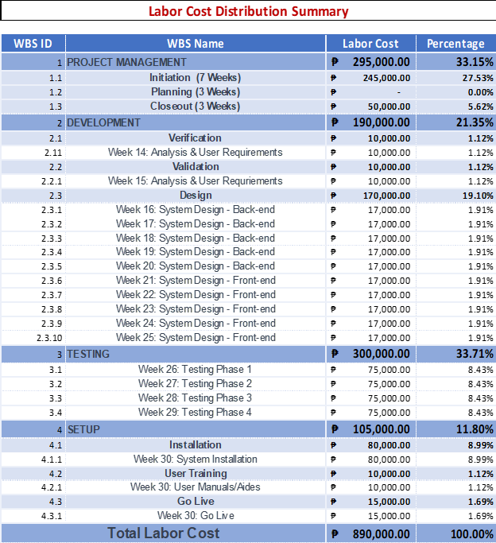

*Figure 6.3—2: Summary of Labor Cost Distribution*

*Image 6.3.6.2: Labor Cost Distribution Summary*

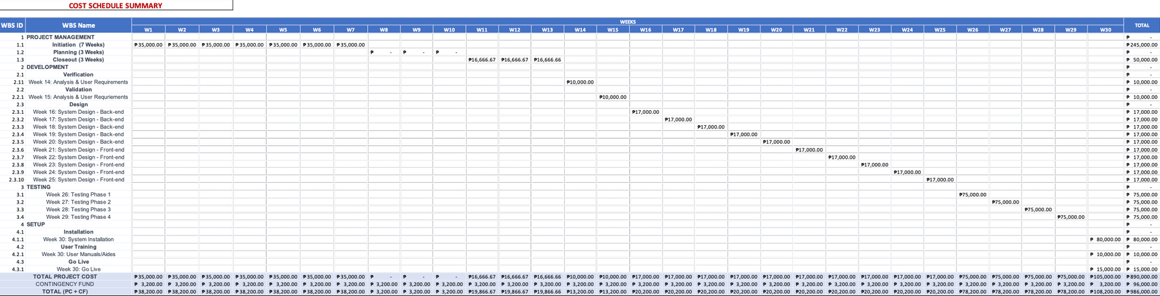

*Figure 6.3—3: Summary of Cost Schedule*

*Image 6.3.6.3: Cost Schedule Summary*

49

## 6.4. Schedule Management Plan

6.4.1. Introduction

The schedule management plan is a crucial component of the Dispatch Directory System project as it outlines the approach and methodology for effectively managing the project timeline and ensuring that the project is completed within the established timeframe. This plan includes the schedule management approach, schedule control, schedule changes and thresholds, and scope change.

1. The schedule management approach outlines the overall strategy and methodology for managing the project schedule.
2. The schedule control provides the processes and procedures for monitoring and controlling the project schedule.
3. The schedule changes and thresholds outline the procedures and processes for managing changes to the project schedule.
4. The scope change outlines the process for managing changes to the project scope.

By creating a detailed and comprehensive schedule management plan, the project team will be able to stay on top of the project schedule, manage and mitigate risks, and communicate effectively with stakeholders and management. This will help to ensure that the project is completed on time, within budget and to the satisfaction of all stakeholders.

6.4.2. Schedule Management Approach

The schedule management plan is a critical component of the Dispatch Directory System project. It is designed to provide a framework for the development and management of the project schedule. The schedule management approach outlined in this document will ensure that the project is completed on time and within budget by providing a clear and comprehensive plan for the project schedule, milestones, and roles and responsibilities.

The schedule management approach for the Dispatch Directory System project will be based on the following principles:

1. **Scheduling Tool/Format:** The project schedule will be created and managed using Google Sheet. This will allow for the creation of a detailed project schedule that includes all tasks, dependencies, and resources required for the successful completion of the project, as well as the ability to share and collaborate with project team members. The Project manager will also provide a Gantt chart for a much more detailed schedule for the project, this will be created using Microsoft Excel.

1. **Schedule Milestones:** The project schedule will be broken down into key milestones that will serve as markers for progress and success. These milestones will be used to track progress, identify potential issues, and will adjust as needed.

The schedule will include the following milestones:

* **Analysis Phase:** The analysis phase of the project will be completed, including the gathering of data needed for the project’s completion and gathering tools that will be needed for the project and identification of areas where improvements can be made.
* **Design Phase:** The design phase of the project will be completed, including the design of the user interface, the determination of the functionalities and features of the system, and the development of a plan for integrating the three tools into a single platform.
* **Implementation Phase:** The implementation phase of the project will be completed, including the coding of various features and functionalities, the integration of the three tools, and the testing of the system to ensure that it is working as intended.
* **Deployment Phase:** The deployment phase of the project will be completed, including the training of users on how to use the system and the provision of ongoing support as needed.
* **System Go-Live:** The dispatch system will be fully operational and available for use by the CREST team.
* **System Review:** A review of the system will be conducted to assess its performance and identify any areas for improvement.
* **Project Close:** The project will be formally closed, and a final report will be prepared documenting the results and outcomes of the project.

**c. Schedule Development Roles and Responsibilities:** The project schedule will be developed and managed by the project manager, in collaboration with the project team. The project manager will be responsible for creating the schedule, updating it as needed, and reporting on progress to stakeholders. The project team members will be responsible for providing input and assistance with the schedule, as well as for meeting their individual task deadlines.

Specific roles and responsibilities for schedule development will include:

* + - * **Project Manager:** Responsible for overall schedule development and management, including creating and updating the project schedule, identifying, and managing schedule risks, and ensuring that the schedule aligns with project objectives.

* + - * **Team Members:** Responsible for providing input and support to the project manager during the schedule development process, including identifying and communicating task dependencies, providing task estimates, and updating task status.

* + - * **Team Leader:** Responsible for providing input and support to the project manager during the schedule development process, including identifying and communicating task dependencies, providing task estimates, and updating task status.

Regular schedule reviews will be conducted to ensure that the project remains on track and that any issues or delays are identified and addressed in a timely manner. The project team will also establish schedule thresholds and change control processes to ensure that any changes to the schedule are managed in a controlled and effective manner.

6.4.3. Schedule Control

The schedule control plan for the dispatch directory system project outlines the procedures and processes that will be used to manage and control the project schedule throughout the life of the project. This includes the following key elements:

• Schedule Updates:

▪ The project schedule will be updated on a regular basis, typically on a weekly or bi-weekly basis, to reflect any changes or progress made on the project.

• Schedule Reviews:

The project schedule will be reviewed by the project team and stakeholders on a regular basis, typically monthly, to ensure that it is accurate and up to date.

This will include reviewing the schedule for completeness, identifying any potential issues or risks, and making any necessary adjustments.

• Communicating the schedule and progress:

The project schedule and progress will be communicated to all stakeholders, including the project team, stakeholders, and management, on a regular basis.

This will be done through regular project status reports, schedule status reports, and other forms of communication as appropriate.

• Roles and responsibilities:

* + - The project manager will be responsible for overall schedule control, including updating and reviewing the schedule, communicating schedule and progress, and making any necessary adjustments to the schedule as needed.
    - The project team members will be responsible for providing accurate and timely information and progress updates to the project manager, which will be used to update the schedule.
    - Stakeholders will be responsible for reviewing the schedule and providing feedback, as well as communicating any schedule changes or requirements that may impact the project.
    - This schedule control plan will be implemented throughout the life of the project, to ensure that the project schedule is accurate, up-to-date, and reflective of the current project status always. This will help to ensure that the project stays on track, that stakeholders are kept informed of progress, and that any potential issues or risks are identified and addressed in a timely manner.

6.4.4. Schedule Changes and Thresholds

The Schedule Changes and Thresholds section of the Schedule Management Plan will outline the procedures for handling schedule changes throughout the project. This includes the boundary conditions set by the project sponsor, which establish the parameters within which the project schedule must operate.

A change threshold of 10% will be used as a guideline for determining when a schedule change request is necessary. This means that any proposed change to the project schedule that exceeds a 10% deviation from the original schedule must be reviewed and approved by the sponsor before it can be implemented. Additionally, it allows the sponsor to consider the potential impact of any schedule changes on the project's budget, resources, and timelines before they are approved.

The boundary conditions that the project sponsor can set to establish the schedule parameters may include:

* + **Project completion date:** The sponsor may set a specific date by which the project must be completed. Any proposed schedule change that would result in the project not being completed by this date must be reviewed and approved by the sponsor.
  + **Milestone completion dates:** The sponsor may set specific dates for certain project milestones to be completed. Any proposed schedule change that would result in a milestone not being completed on the specified date must be reviewed and approved by the sponsor.
  + **Resource constraints:** The sponsor may set limits on the resources available for the project. Any proposed schedule change that would result in exceeding these resource constraints must be reviewed and approved by the sponsor.
  + **Budget constraints:** The sponsor may set a specific budget for the project. Any proposed schedule change that would result in exceeding this budget must be reviewed and approved by the sponsor.

For example, if the original project schedule estimated a task to take 20 days to complete, and a proposed change would increase that task's duration to more than 22 days, a schedule change request would be necessary, and the sponsor would need to review and approve the change before it can be implemented.

Another example, the project sponsor has set a completion date of December 31, 2023, for the Dispatch Directory System project. The project schedule has been set to complete all the activities by this date. However, due to unforeseen issues, a proposed schedule change must be made to push the completion date to January 15, 2024. This change exceeds the 10% change threshold, so it must be reviewed and approved by the sponsor before it can be implemented.

6.4.5. Scope Change

The scope change process will be implemented to ensure that any new deliverables or requirements that were not previously considered as part of the original schedule’s development are properly managed and integrated into the project.

The process will include the following steps:

**1. Identification of the scope change**

a. The project team will identify any new deliverables or requirements that need to be added to the project.

**2. Impact assessment**

* + - * 1. The project team will assess the impact of the scope change on the project schedule and resources.
        2. This will include an evaluation of the additional time and resources required to complete the new deliverables or requirements, as well as any potential delays to the project schedule.

**3. Schedule and resource analysis**

a. The project team will analyze the current status of the project schedule and resources to determine how the scope change will affect the project moving forward.

**4. Approval process**

* + - 1. The scope change will be reviewed and approved by the project sponsor and key stakeholders.
      2. The project sponsor will make the final decision on whether or not to proceed with the scope change.

**5. Implementation**

a. Once the scope change is approved, the project team will integrate the new deliverables or requirements into the project schedule and resources.

**6. Monitoring and control:**

a. The project team will monitor the progress of the scope change and make any necessary adjustments to the project schedule and resources to ensure that the project remains on track.

**7. Closeout:**

a. The scope change will be closed out once all new deliverables or requirements have been completed and the project schedule and resources have been updated accordingly.

It is important to note that scope changes can have a significant impact on the project schedule and resources and must be managed carefully to ensure that the project stays on track and within budget.

## 6.5. Staffing Management Plan

6.5.1. Introduction

The human resource management strategy is critical for finding, assigning, and managing resources are described in the staffing management plan. It guarantees that the correct people with the necessary experience and abilities are given project roles and responsibilities. This strategy is to maximize resource use, encourage good communication, and support the project's successful execution.

By following this plan, the product owner and development team can successfully manage the project by making sure that everyone on the team is aware of their respective roles and responsibilities, that communication is clear and effective, and that performance is tracked and managed in a way that supports the project's success.

6.5.2. Roles and Responsibilities

An effective human resources management plan is crucial for the successful completion of any project. The terms "roles and responsibilities" are used to describe the tasks, obligations, and areas of responsibility given to people or teams working on the project. These roles and duties are crucial for the project's successful execution and seamless execution. Roles and duties in consolidated project management are described as follows:

|  |  |  |  |
| --- | --- | --- | --- |
| **Role** | **Authority** | **Responsibility** | **Competency** |
| Project Sponsor | The one’s responsible for initiating, ensuring, and approving of the project. | Ensures that the project funding model and approves sources of financing. Assists the team and the product owner. | Maintaining strong leadership qualities and the capacity for strategic thought, as well as the capacity for effective stakeholder communication. |

|  |  |  |  |
| --- | --- | --- | --- |
| Product Owner | Has the authority to make decisions regarding the product backlog, product vision and the prioritization of requirements and features. | To represent the interests of the stakeholders and ensure that the product meets their needs and expectations. They are responsible for defining and prioritizing the product backlog, ensuring that it is visible, transparent, and understood by the development team. | The Product Owner should have the ability to prioritize effectively, balancing competing interests and managing the product backlog to maximize value. |

|  |  |  |  |
| --- | --- | --- | --- |
| Project Manager | Making the decision for the project and responsible for designating task | Control and oversee all aspects of the project, including its planning, requirements gathering, system design, system development, implementation, and project management. Make sure that the project’s goals are attained on schedule, within budget, and with the appropriate level of quality. | Has a solid understanding of project management principles, methodologies, and best practices. |
| Project Documentation Manager | The Project Documentation Manager has the authority to establish and enforce documents management policies and procedures within the project | The Documentation Manager is responsible for planning the documentation activities throughout the project lifecycle. This includes identifying documentation needs, setting priorities, and establishing timelines | The Documentation Manager should possess strong writing skills, technical understanding, and knowledge of industry-specific documentation standards. |
| Scrum Master | The Scrum Master has the authority to facilitate the Scrum process, ensuring that the team adheres to Agile principles and follows Scrum practices. | The primary responsibility of a Scrum Master is to facilitate the Scrum process, including organizing and facilitating Scrum events to ensure effective collaboration and progress | The Scrum Master must have a deep understanding of Agile principles and Scum practices. They should be well-versed in Scrum artifacts, ceremonies, and roles. |
| Scrum Member | Scrum Team members have the authority to actively participate in decision-making processes related to project, including task estimation, task allocation, and determining how to achieve the sprint goals | Scrum Team members are responsible for collaboratively working towards achieving the sprint goals. They contribute to the planning, development, testing, and delivery of product increment | Team members are expected to possess the necessary skills and knowledge related to their respective areas of expertise. This includes technical skills, domain-specific knowledge, and understanding of Agile principles |

6.5.3. Project Organizational Charts

Project organizational chart of the Inventory and Ordering system provides a visual representation of the project team and the relationships between the key stakeholders.

They show the duties and tasks of those participating in the project. The charts enable efficient communication and decision-making while clearly illustrating the project team's makeup.

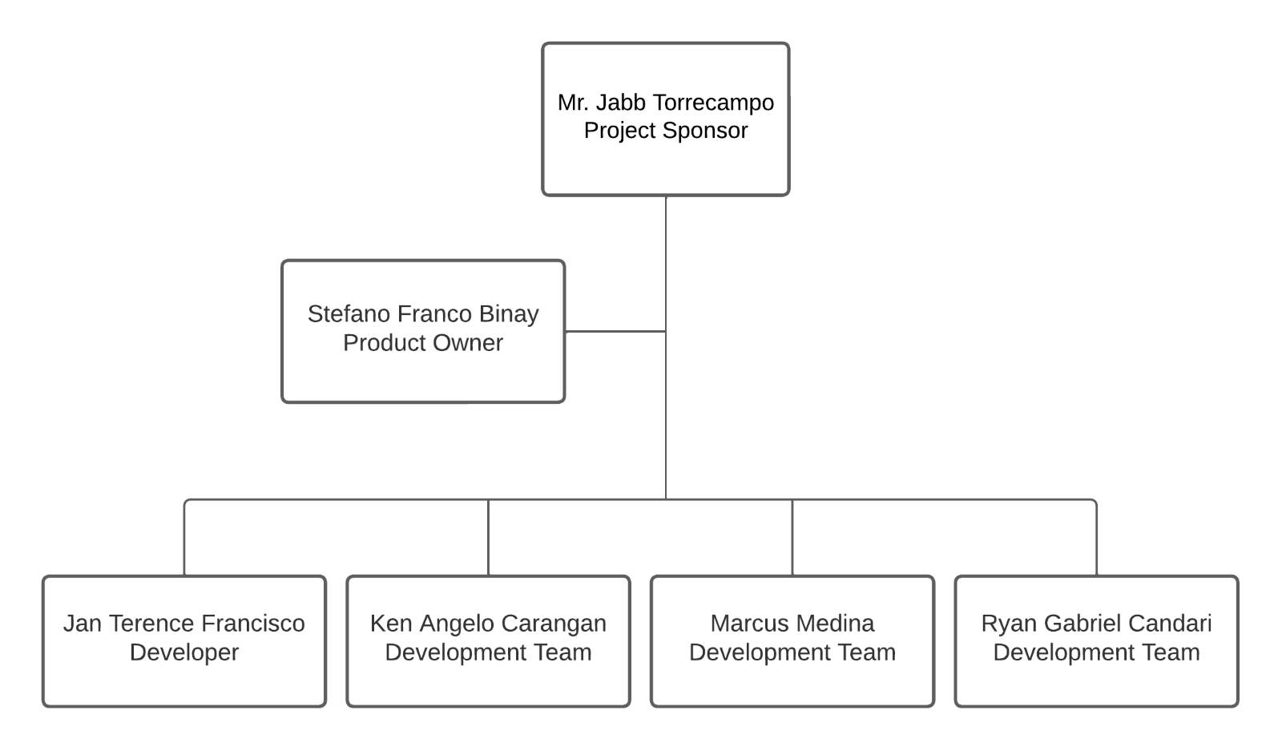

*Figure 6.5—1: Project Organizational Chart*

6.5.4. Staffing Management

The Staffing Management Plan for the Inventory and Ordering System project is a critical component in ensuring the successful execution of the project. It outlines the strategies and processes for acquiring, managing, and releasing human resources throughout the project lifecycle.

* To address any skill gaps identified, appropriate training will be provided to enhance knowledge and capabilities. This includes both on-the-job training and formal training programs.
* Regular performance reviews will be conducted to evaluate team members' performance and identify areas for improvement. These reviews will provide feedback on how well team members are meeting project expectations and objectives.
* To acknowledge and motivate outstanding performance, a rewards and recognition system will be implemented. This may include bonuses, promotions, and other incentives.

|  |  |  |  |  |  |
| --- | --- | --- | --- | --- | --- |
| **Role** | **Project Responsibility** | **Skills Required** | **Number of**  **Staff** | **Performance Reviews** | **Recognition and Rewards** |
| Product Owner | Ensuring that the product meets the needs and expectations of stakeholders.  Providing guidance and clarifications to the development team during development. | Excellent communication and collaboration skills.  Strong problem-solving and analytical skills.  Strong leadership and decision-making skills. | Depends on the scope and complexity of the project.    Determined in collaboration with other stakeholders | The project manager will conduct regular performance  reviews with team members  to assess their progress, provide feedback, and address any issues. | The product owner will implement a recognition and rewards system to  motivate  team members and encourage high performance. |
| Scrum Master | Developing and implementing the project's software or application according to the defined requirements. | Leadership    Communication  Problem Solving  Analytical Skills | Depends on the scope and complexity of the project. | The project developer will  work with team members  to set achievable performance goals and track their progress | This can include acknowledgment for exceptional coding skills, solving complex technical problems, delivering high-quality software, and meeting project milestones. |

|  |  |  |  |  |  |
| --- | --- | --- | --- | --- | --- |
| Scrum Member | Collaborating with stakeholders to gather requirements and understand project goals.    Participating in project planning, estimation, and task allocation. | Technical skills related to the project.    Communication    Collaboration and teamwork    Problem-solving    Time management | Depends on the scope and complexity of the project.    Determined in collaboration with other stakeholders | These reviews evaluate their technical skills, teamwork, adherence to project timelines and quality standards, problem-solving abilities, and overall project delivery. | Rewards may include bonuses, promotions, certificates, or opportunities for career growth within the organization. |
| Project Sponsor | Allocate resources and secure funding for the project. Act as the primary point of contact between the project team  and senior  management    Monitor project progress and provide guidance and support to the project team | Leadership    Strategic thinking    Communication  Risk  management | May be supported by a project  management | The review process may consider the Sponsor's ability to contribute to project success and stakeholder satisfaction. | Rewards may include acknowledgment from senior management, promotions, bonuses, or other forms of recognition based on their contribution to project success and overall organizational benefits. |
| Project Documentation Manager |  |  |  |  |  |

*Table 6.5—2: Staffing Management*

## 6.6. Change Management Plan

6.6.1. Introduction

The process and procedures for managing changes throughout the course of a project's duration are described in the change management plan. It seeks to decrease interruptions, preserve project stability, and guarantee successful change implementation. This plan will include instructions on how adjustments are found, considered, accepted, and put into action to effectively complete the project's goals.

6.6.2. Change Control Board

The Change Control Board is responsible for reviewing and approving proposed changes. The CCB consists of key stakeholders and decision-makers who assess the impact, risks, and benefits of proposed changes.

|  |  |  |  |  |
| --- | --- | --- | --- | --- |
| **Change**  **Control**  **Board**  **Role** | **Role** | **Name** | **Contact** | **Responsibilities** |
| Change  Control  Board  Chair | Project  Sponsor | Mr. Maria Theresa Reyes | [mtrf24@gmail.com](mailto:mtrf24@gmail.com) | Monitor project progress and provide guidance and support to the project team. |

|  |  |  |  |  |
| --- | --- | --- | --- | --- |
| Change  Control  Board  Member | Project  Owner | Stefano Franco Binay | [Ssjbinay@student.apc.edu.ph](mailto:Ssjbinay@student.apc.edu.ph) | Ensuring that the product meets the needs and expectations of stakeholders. |
| Change  Control  Board  Member | Developer | Jan Terrence Francisco | jrfrancisco@student.apc.edu.ph | Ensures that the  Developing and implementing the project's software or application according to the defined requirements. |
|  |  |  |  |  |

*Table 6.6—1: Change Control Board*

6.6.3. Roles and Responsibilities

The table below shows the respective responsibilities of each member of the project that in the change management process:

|  |  |  |
| --- | --- | --- |
| **Name** | **Project Role** | **Responsibilities** |
| Maria Theresa Reyes | Project  Sponsor | Submit change request if deemed necessary  review the change request log and reports to ensure alignment with changes. |
| Ryan Gabriel Candari | Project Documentation Manager | Submit a change request if deemed necessary  review the change request log and reports to ensure alignment with changes. |
| Marcus Medina | Scrum Member | Submit a change request if deemed necessary.  review the change request log and reports to ensure alignment with changes. |
| Ken Angelo Carangan | Product Owner | Submit a change request if deemed necessary  review the change request log and reports to ensure alignment with changes. |
| Stefano Franco Binay | Project Manager | Submit a change request if deemed necessary review the change request log and reports to ensure alignment with changes. |
| Jan Terence Francisco | Scrum Master | Execute the technical aspect of the change request action plan.  Review the change request log and reports to ensure alignment with changes. |

*Table 6.6—2: Change Request Roles and Responsibilities*

6.6.4. Change Control Process

The Change Control Process outlines the procedures throughout the project. It ensures that changes are properly evaluated, approved, and implemented in a controlled and systematic manner. The process typically involves the following stages:

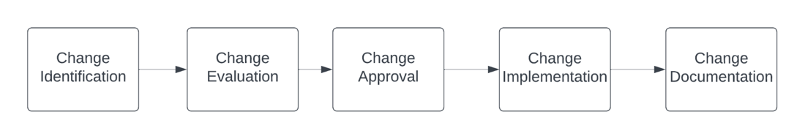

*Figure 6.6—1: Change Control Process (High Level)*

|  |  |  |
| --- | --- | --- |
| **Process step** | **Description** | **Change Log Status** |
| Change Identification | 1. The project manager and sponsor willfill out and submits the  change request form to initiate the request. | Submitted |
| Change Evaluation | 1. After receiving the request, the **Project**   **Manager** and **Product Owner** will assess the impact of the change request.   1. If the impact is high, the **Project Manager** will then prepare a recommendation to approve. 2. The **Change Coordinator** will update the   Change Log and create a Change Status Report. | In Review |

|  |  |  |  |
| --- | --- | --- | --- |
| Change Approval |  | 1. The **Product Owner** has the ability to accept or reject an approval. | Approved or denied |
| Change Implementation | | 1. After the approval the changes is subject to implement in the system. | In Progress |
| Change Documentation | | 1. **Project Manager** verifies that the change   has been implemented and reports to the Change Control Board.   1. The **Change Coordinator** will update the   Change Log and create a Change Status Report. | Verifying |
| Change Request  Closure | | 1. The **Change Coordinator** will send out the final the Change Status Report across the team and stakeholders. | Closed |

*Table 6.6—3: Change Request Process*

To keep track of the change request progress, each step has a corresponding change request status as show on the table below:

|  |  |
| --- | --- |
| **Status** | **Description** |
| Submitted | A member of the project development team or key stakeholders submitted a change request log and has not been reviewed by the Project Manager for impact analysis. |
| In Review | Impact analysis is being performed. |
| Approved | Change request is approved and will be moved to implementation. |
| Denied | Change request is denied. |
| In Progress | Action plan to execute the change request is being implemented |
| Verifying | Review of proper implementation of change request |
| Closed | Chang request work is complete, has passed all tests, and updates have been released. |

*Table 6.6—4: Change Request Status Description*

## 6.7. Communications Management Plan

6.7.1. Introduction

The Communications Management Plan is a critical component of the Inventory and Ordering System project as it outlines the communication strategy and protocols for the project team and stakeholders. The plan defines the following:

1. The plan outlines the type of information that will be communicated, such as project updates, progress reports, risks, and issues. It also includes the level of detail and format of the information, such as whether it will be communicated verbally or in written form.
2. The plan outlines the methods of communication that will be used, such as meetings, email, telephone, web portal, etc. This ensures that all stakeholders are informed in a timely manner.
3. The plan outlines the frequency of project communications, both formal and informal, to ensure that stakeholders are kept informed on a regular basis.
4. The plan defines the roles and responsibilities of team members and stakeholders in terms of communication, including who is responsible for disseminating project information.
5. The plan outlines the specific communication needs of all stakeholders and how they will be met, such as language requirements and accessibility.
6. The plan outlines the resources allocated for communication, such as budget and personnel, to ensure that communication is effective and efficient.
7. The plan outlines the protocols for communicating sensitive or confidential information, including who must authorize the release of such information.
8. The plan defines a process for managing changes in communication or the communication process, including how changes are proposed, reviewed, and approved. This ensures that all stakeholders are aware of any changes and that the communication process remains consistent throughout the project.
9. The plan outlines the flow of communication within the project, including how information is shared between team members, stakeholders, and other project partners. This helps to ensure that all stakeholders are informed, and that information is shared in a timely manner.
10. The plan identifies any internal or external constraints that may affect project communications, such as legal or regulatory requirements, and outlines how these constraints will be addressed.
11. The plan outlines any standard templates, formats, or documents that must be used for communicating project information, such as progress reports or meeting minutes. This ensures that all stakeholders are provided with consistent and accurate information.
12. The plan includes an escalation process for resolving any communication-based conflicts or issues that may arise during the project. This helps to ensure that any communication-related issues are addressed and resolved in a timely manner.

Overall, the Communications Management Plan is a key tool that helps to ensure that all stakeholders are informed, and that communication is effective and efficient throughout the Dispatch Directory System project.

6.7.2. Communications Management Approach

The best communications management approach for the Dispatch Directory System project would be a combination of proactive and reactive strategies.

Proactively, regular project status meetings will be held to ensure all stakeholders are informed and aware of the project’s progress. The project manager will hold regular meetings with the project team and communicate any updates, progress reports, risks, and issues. This will provide stakeholders with an overview of the project’s status and any potential roadblocks. Additionally, a project website and web portal will be created to provide stakeholders with easy access to project information, such as meeting minutes, documents, and project status reports.

Reactively, a clear and concise escalation process will be established to address any communication-based conflicts or issues that arise. The project manager will be readily available to stakeholders to answer any questions or concerns they may have and provide support and guidance when needed.

In addition, a change control process will be implemented to manage any changes in communication or the communication process. This will ensure that any changes are approved by the Change Control Board and that stakeholders are informed of any changes in a timely manner.

Overall, this approach ensures that the project team and stakeholders are kept informed and that any communication-based issues are handled in an efficient and effective manner.

6.7.3. Communications Management Constraints

The Communications Management Constraints for the Inventory and Ordering System project are a crucial aspect of the overall project management plan. These constraints help to define the limitations and boundaries that may impact the communication processes and strategies of the project. By identifying and addressing these constraints, the project team can proactively develop solutions to mitigate potential challenges and ensure the smooth flow of information throughout the project.

This section of the Communications Management Plan will provide an overview of the key constraints that may impact the project's communication processes, including internal and external factors, technological limitations, and regulatory requirements.

Communications management constraints for the Inventory and Ordering System project may include:

1. **Limited budget for communication tools and resources:** The project may have a limited budget for communication tools and resources, such as video conferencing software, project management software, or hiring a dedicated communications team.

1. **Limited access to certain stakeholders:** Some stakeholders may be located in remote locations or have limited access to certain forms of communication, such as email or internet.

1. **Limited availability of team members:** Team members may have other commitments or responsibilities that limit their availability for communication.

1. **Language barriers:** If team members or stakeholders speak different languages, there may be a need for translation services or additional resources to facilitate communication.

1. **Confidentiality:** Some information related to the project may be confidential and require special handling and communication protocols.

1. **Resistance to change:** Some stakeholders may be resistant to changes in communication processes or tools, which can make it difficult to implement new communication strategies.

1. **Technical difficulties:** Technical difficulties with communication tools and systems can also be a constraint.

1. **Time constraints:** The project may be under a tight deadline, which can make it challenging to schedule and hold regular communication meetings.

6.7.4. Stakeholder Communication Requirements

The Stakeholder Communication Requirements are a vital component of the Dispatch Directory System project as they outline the specific communication needs of all stakeholders involved in the project. Effective communication is essential for ensuring that the project is completed on time, within budget, and to the satisfaction of all stakeholders. By identifying and addressing the communication requirements of stakeholders, the project team can proactively manage expectations, build trust, and foster collaboration.

This section of the Communications Management Plan outlines the specific communication needs of stakeholders and how they will be met throughout the project's lifecycle.

The stakeholder communication requirements for the Dispatch Directory System project would likely include:

1. **Regular project updates:** All stakeholders should be informed of the project's progress, including any issues or risks that may arise.
2. **Clear and concise communication:** All project-related information should be communicated in a clear and concise manner, ensuring that stakeholders understand the message.
3. **Accessibility:** Communication should be accessible to all stakeholders, considering any language or accessibility needs.
4. **Timely communication:** Information should be communicated in a timely manner, ensuring that stakeholders are informed as soon as possible.
5. **Confidentiality:** Any sensitive or confidential information should be communicated to only the necessary stakeholders and handled in a secure manner.
6. **Customized communication:** Communication should be tailored to the specific needs of each stakeholder, considering their level of involvement in the project and their role.
7. **Two-way communication:** Communication should be a two-way process, allowing stakeholders to provide feedback and ask questions.
8. **Feedback mechanisms:** A mechanism for stakeholders to provide feedback on the communication process should be in place to ensure that communication is effective.

6.7.5. Roles

|  |  |
| --- | --- |
| **Role** | **Responsibility** |
| Project Sponsor | Ensures that the project funding model and approves sources of financing. Assists the team and the product owner. |

|  |  |
| --- | --- |
| Product Owner | To represent the interests of the stakeholders and ensure that the product meets their needs and expectations. They are responsible for defining and prioritizing the product backlog, ensuring that it is visible, transparent, and understood by the development team. |

|  |  |
| --- | --- |
| Project Manager | Control and oversee all aspects of the project, including its planning, requirements gathering, system design, system development, implementation, and project management. Make sure that the project’s goals are attained on schedule, within budget, and with the appropriate level of quality. |
| Project Documentation Manager | The Documentation Manager is responsible for planning the documentation activities throughout the project lifecycle. This includes identifying documentation needs, setting priorities, and establishing timelines |
| Scrum Master | The primary responsibility of a Scrum Master is to facilitate the Scrum process, including organizing and facilitating Scrum events to ensure effective collaboration and progress |
| Scrum Member | Scrum Team members are responsible for collaboratively working towards achieving the sprint goals. They contribute to the planning, development, testing, and delivery of product increment |

*Table 6.7—1:Communication Management Roles and Responsibilities*

6.7.6. Project Team Directory

The following table presents contact information for all persons identified in this communications management plan. The email addresses and phone numbers in this table will be used to communicate with these people.

*Table 6.7—2: Project Team Directory*

6.7.7. Communication Methods and Technologies

The Dispatch Directory System project requires a thorough understanding of the various communication methods and technologies that will be used to effectively communicate with all stakeholders. It is important to consider the different capabilities and limitations of each communication method and technology, in order to ensure that all stakeholders receive the information they need in a timely and efficient manner. This includes determining the appropriate methods for delivering project updates, progress reports, risks, and issues, as well as any other relevant information.

Additionally, it is important to consider the cost and feasibility of using different technologies, as well as any security or privacy concerns that may arise. By carefully selecting the most appropriate communication methods and technologies, the project team can ensure that all stakeholders are kept informed and that the project's communication objectives are met.

When determining the best communication methods and technologies for the Dispatch Directory System project, several factors should be considered. These include:

* **The size and complexity of the project: For** large and complex projects, web portals and project management software may be the best option as they allow for the centralization of information and easy access for all stakeholders.
* **The location of stakeholders:** For stakeholders that are in different geographical areas, video conferencing and telephone may be the best option as they allow for real-time communication.
* **The level of technical expertise of stakeholders:** For stakeholders that are not technically proficient, simple communication methods such as email and telephone may be the best option.
* **The type of information being communicated:** For sensitive or confidential information, secure methods such as encryption and password-protected portals may be necessary.
* **The budget and resources available:** The communication methods and technologies that are chosen should be within the project budget and resources.

Based on these factors, it is recommended that the Dispatch Directory System project utilizes a combination of communication methods and technologies such as project management software, email, telephone, and video conferencing to ensure that all stakeholders are kept informed and that the project's communication objectives are met.

6.7.8. Communications Matrix

|  |  |  |  |  |  |  |
| --- | --- | --- | --- | --- | --- | --- |
| **Channel** | **From** | **To** | **Type** | **Frequency** | **Format Used** | **Delivery media** |
| Project  Planning | Project  Manager | Stakeholders | Meeting | Once Before the start of the project | Formal | Email |
| Release planning | Project manager, Project team | Stakeholders | Meeting | Once before start of the  project Updated when  necessary | Formal | Email |
| Sprint  Planning | Project manager | Project team | Meeting | Once every week | Informal | Google  Spaces |
| Management  processes | Project  manager, project team | Stakeholders | Artifact | Once Before start of the  project Updated when  necessary | Written  Document | Email,  Google  Spaces |
| Product backlog | Project manager | Project team | Artifact | Once every week | Written  Document | Google  Spaces |
| Project update | Project  Manager | Project team | Meeting | Once every week | Informal | Google  Spaces |

*Table 6.7—3: Communication Matrix*

6.7.9. Communication Flowchart

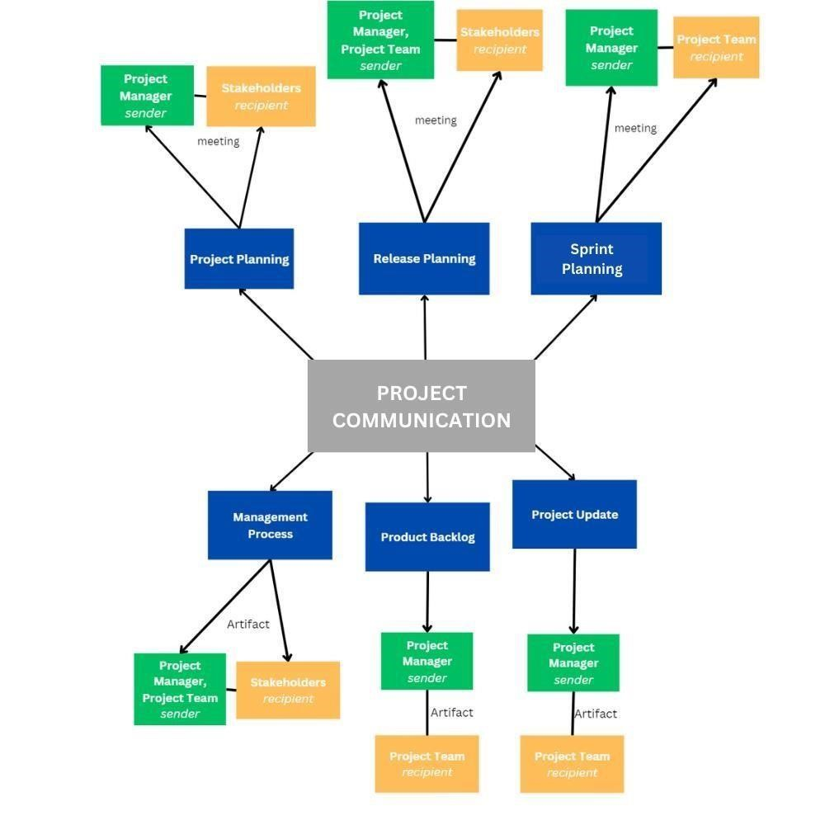

*Figure*

*6.7*

*—*

*1:*

*Communication Flowchart*

6.7.10. Guidelines for Meetings

Meetings are a key component of effective communication in any project. The Dispatch Directory System project is no exception. In order to ensure that meetings are productive, efficient, and effective, it is important to establish clear guidelines for meetings. These guidelines should include information on the purpose of meetings, the roles and responsibilities of attendees, and the procedures that will be followed during meetings.

By having a set of well-defined guidelines for meetings, project team members and stakeholders can be better prepared for the meetings and can participate more effectively in the discussions. Additionally, the project manager can ensure that meetings are conducted in a consistent and organized manner, which can help to avoid confusion and misunderstandings.

Below are the meeting guidelines for Dispatch Directory System project:

* **Purpose**: Meetings are an essential part of the Dispatch Directory System project and are used to discuss project progress, resolve issues, and make decisions.
* **Scheduling**: Meetings should be scheduled in advance and at a time that is convenient for all attendees. The project manager is responsible for scheduling meetings and sending out invitations.
* **Attendance**: All project team members and stakeholders are expected to attend meetings unless they have a valid excuse. If a team member is unable to attend, they should inform the project manager as soon as possible.
* **Agenda**: An agenda should be circulated in advance of the meeting, outlining the topics to be discussed and the expected outcome of the meeting. This will ensure that attendees are prepared and that the meeting stays on track.
* **Minutes**: Minutes should be taken during the meeting and distributed to all attendees within 24 hours. The minutes should include a summary of the discussions, decisions made, and action items assigned.
* **Decisions**: Decisions should be made by consensus whenever possible. If a consensus cannot be reached, the project sponsor has the sole authority to decide.
* **Action items:** Action items should be assigned during the meeting and a followup date set to ensure that they are completed on time.
* **Follow-up**: The project manager is responsible for following up on action items and ensuring that they are completed on time.
* **Communication**: Meetings are a means of communicating project progress and addressing issues. Attendees should be encouraged to communicate openly and honestly.
* **Technology**: Meetings should be held using technology that is accessible to all attendees. This may include video conferencing, teleconferencing, or web conferencing.
* **Time management**: Meetings should start and end on time and should not exceed the allotted time. This will ensure that attendees are not kept waiting and that the project stays on schedule.
* **Evaluation**: Meetings should be evaluated regularly to ensure that they are productive and that attendees are satisfied with the outcome. Any issues should be addressed and improvements.

6.7.11. Communication Standards

The best communication standards for the Dispatch Directory System project may include the following:

* **Standardized Templates:** Developing and using standard templates for project communications, such as status reports, meeting agendas, and minutes, can ensure consistency and clarity in the information being shared.
* **File Naming Convention:** Developing a standard file naming convention for documents and files shared on the project can help ensure easy access and organization of information.
* **Web Portal/Network Tool:** Utilizing a standard platform, such as SharePoint or project management software, for project communication can improve access to information and collaboration among team members and stakeholders.
* **Video conferencing:** Use of Video conferencing tools like Google Meets, Zoom, Skype, etc. can be very useful for team members and stakeholders who are located at different geographic locations.
* **Communication protocols:** Having a standard communication protocol in place for sensitive or confidential information, such as who is authorized to share it and how it should be shared, can ensure the protection of sensitive data.

6.7.12. Communication Escalation Process

The ideal and best communication escalation process for the Dispatch Directory System project would involve the following steps:

1. **Identify the issue:** The project team should first identify the communication related issue that needs to be escalated.
2. **Attempt to resolve the issue within the team:** The project team should make an initial attempt to resolve the issue within the team by discussing it with the relevant team members and trying to find a solution.
3. **Involve a communication manager:** If the issue cannot be resolved within the team, the team should involve a communication manager or a designated person responsible for communication within the organization. This person will act as a liaison between the project team and the stakeholders and help to resolve the issue.
4. **Escalate to higher management:** If the issue still cannot be resolved, it should be escalated to higher management for further review and resolution.
5. **Document the issue and resolution:** Throughout the escalation process, it is important to document the issue, the steps taken to resolve it, and the final resolution to ensure that proper records are kept for future reference.
6. **Review and Improve:** After the escalation process, review the process to identify what can be improved for future escalations.

It's important to note that the escalation process should be flexible and adaptable to the specific needs of the project. The project team should review the escalation process regularly to ensure that it remains effective and efficient in addressing communication related issues.

6.7.13. Glossary of Communication Terminology

|  |  |
| --- | --- |
| **Term Definition** | |
| **Communication Plan** | A document outlining the communication strategy and protocols for the project team and stakeholders. |
| **Stakeholder** | An individual or organization that has an interest or concern in the project. |
| **Communication Method** | The means by which information is conveyed, such as meetings, email, telephone, or web portal. |
| **Communication Frequency** | The regularity with which project communications are distributed. |
| **Communication Objective** | The desired outcome or goal of a particular communication. |
| **Communication Flowchart** | A diagram showing the flow of information within a project. |
| **Escalation Process** | A procedure for resolving communication-based conflicts or issues. |
| **Communication Matrix** | A table outlining the communication requirements for a project. |
| **Communication Standards** | Standard templates, formats, or documents used for communicating within a project. |
| **Communication Constraints** | Factors that may limit or affect the effectiveness of project communications. |
| **Communication Guidelines** | Protocols for conducting meetings, teleconferences, and other forms of communication. |
| **Communication Technology** | Tools and platforms used for communication, such as  SharePoint, message boards, and video teleconferencing. |
|  |  |
| **Communication**  **Escalation Process** | A process for escalating communication-based issues or conflicts that cannot be resolved within the project team. |
| **Communication Approaches** | Different strategies and solutions are implemented to address communication constraints, ensuring that all stakeholders are kept informed and that the project's communication objectives are met. |

*Table 6.7—4: Glossary of Communication Management Terminologies*

## 6.8. Quality Management Plan

## Quality Management Plan

**Introduction**

This will be the quality management plan for the IO system that will be given to Torrecamps Marketing, the plan would aid the group in ensuring that the quality of the system would be what the client needs. The plan would help in defining the quality of the output as well as maintaining it, since the proposed system contains many variables this quality management plan would aid in ensuring that each and every part of the system would be to the clients satisfaction.

**Goals of the Quality Management Plan**

* Make sure the system satisfies or exceeds the expectations of the client
* List down the criteria the group will follow for the quality of the project
* Clarify the roles and responsibilities of the group members
* Determine and fix the quality problems that the group are or may face
* Establish a structure to manage and uphold the quality of the system throughout the course of the project

**A quality management plan’s tools include:**

* **Definition of Done:** This tool will help in determining when the project is deemed “Done”, it is a clear explanation of what makes a finished product.
* **Acceptance Criteria:** This will help define what requirements a product must meet for the product owner to approve of the output.
* **Continuous Integration:** Atechnique for regularly integrating code updates into a repository so that the final product is always ready for release.
* **Test-Driven Development:** A method of development that calls for the creation of automated tests before any code is written in order to guarantee that the code satisfies required quality.

This plan will aid the group in ensuring that the quality of the project will be accepted by the client by being a comprehensive framework for managing and maintaining project quality throughout the project’s lifecycle. This will ensure that the project will at least meet the expectations of the client, while providing a clear process, tools, and roles and responsibilities for identifying and addressing the quality issues that the group may face.

**Quality Management Approach**

The Quality Management Plan for the IO system will utilize an Agile and Scrum method to ensure that the project meets or exceeds the clients quality expectations. This approach will prioritize delivering high-quality products and meeting customer requirements over following rigid processes.

These are the roles and duties for the quality management plan

|  |  |
| --- | --- |
| Role | Description |
| Project Manager | The person in charge of establishing the acceptance standards and making sure the final product satisfies all stake holders |
| Project Team Leader | The one in charge of checking if the team adheres to the framework set and is also the one who works with the Product Owner and Development team to enhance the final product. |
| Project Development team | They are responsible for producing a high-caliber product and upholding the specified quality policies and standards. |
| Project Sponsor | Provides executive support for the project. |

**The approach will include the following steps:**

1. **Define quality standards** – The group will define quality standards based on the Agile and Scrum methodology, with a focus on delivering value to the customer.
2. **Quality planning** – The group will work closely with the stakeholders ensuring that the project requirements are met while prioritizing the most important features. The group will then create a product backlog so that they can monitor the changes made and so that they can ensure the quality of the system with each iteration released.
3. **Quality control –** Quality control measures will be implemented during the sprint to ensure that the product meets the defined requirements and quality goals. Testing and reviews during each sprint are included to identify any defects or issues.
4. **Quality Assurance** – Quality assurance measures to prevent defects and issues from occurring will be implemented. The group will use the best available practices and processes to ensure that the project is being executed according to the established standards and guidelines.
5. **Continuous Improvement** – The group will continuously monitor the and evaluate the system’s performance and adjust when necessary. This will include collecting and analyzing feedback from the stakeholders, identifying areas of improvement, and implementing changes to improve the project’s overall quality.
6. **Communication** – The group will maintain constant communication with the stakeholders in order to make sure that they are aware of the product’s quality status and can provide feedback as needed.

The project team will incorporate Agile and Scrum practices, including user stories, sprints, and retrospectives, to ensure that quality is built-in throughout the project's lifecycle and meets the organization's quality standards and the needs of the project stakeholders. In addition, a risk management plan will be developed to proactively identify and mitigate potential quality risks throughout the project's lifecycle.

Overall, the Quality Management Approach for IO system and will prioritize delivering a high-quality product that meets customer requirements through an Agile and Scrum method. The approach will be flexible and continuously refined to ensure that the project meets or exceeds all quality expectations.

**Requirements/Standards**

The IO system places a high focus on quality, and the team will cooperate to create and record quality requirements and standards. Client comments, testing, and assessments will be used to guarantee adherence to these criteria. The following requirements and standards for quality will be followed by the IO system.

**Requirements for Product Quality:**

* The IO system will be fully operational and adhere to the product’s backlog technical requirements.
* The interface will be easy to use with a simple design that will be easy to navigate.
* The solution will be implemented with a new technological infrastructure.

**Requirements for Ensuring Quality of Processes:**

* The product owner and development team will review and approve all project deliverables prior to being provided to the client
* The development team will implement an ongoing process of testing and quality assurance to ensure that the system meets all technical specifications and requirements.
* A version control tool will be used by the development team to ensure that any modifications to the system are properly documented, reviewed and authorized.

**Compliance Demonstration:**

* The IO system will be tested and evaluated against the established quality requirements and standards before being deployed to the client.
* The development team will maintain comprehensive documentation of all testing and
* quality assurance activities, which will be made available to the client upon request.
* The development team will conduct a formal acceptance test with the client to ensure that the system meets their requirements and expectations.
* The development team will provide ongoing support and maintenance services to ensure that the system continues to meet the established quality standards over time.

**Continual Improvement**

The development team will design a method for continual improvement by routinely gathering an analyzing client feedback, monitoring system performance, and carrying out internal audits to spot improvement areas.

**Quality Assurance**

QA process for the IO system will be integrated into the Agile and Scrum method to ensure that the quality is achieved through collaborative effort and continuous improvement as the following steps will be undertaken:

* **Defining quality standards** – The group will collaborate with stakeholders to define and document the quality standards for the project in the quality management plan. The quality standards will constantly be communicated to all stakeholders.
* **Agile Quality Auditing:** The group will conduct regular quality audits using Agile practices such as peer reviews, test-driven development, and continuous integration. These practices will be used to verify that quality standards are being met and identify areas for improvement.
* **Quality Metrics:** The group will use quality metrics to track and report on the project's performance against the quality standards

To monitor the quality process, the following metrics will be used:

* Agile Metrics such as Velocity, Burn-Down Charts, and Sprint Reviews
* Defect Density: The number of defects found per unit of measure (e.g., per KLOC)
* Defect Severity: The classification of defects based on their impact on the system

* Test Coverage: The percentage of the system that has been tested

* Test Case Pass Rate: The percentage of test cases that have been passed
* Root Cause Analysis Effectiveness: The percentage of issues that have been resolved at the root cause level.

**Continuous Improvement:** The group will use the feedback received from quality audits and quality metrics to continuously improve the product and the quality process. The project team will work with stakeholders to identify opportunities for improvement and implement changes.

**Compliance with Industry Standards:** The group will ensure that the IO System adheres to relevant industry standards such as accessibility standards, security standards, and data privacy regulations. Regular audits will be conducted to verify compliance with these standards.

**Reviewing Customer Feedback:** The group will regularly review customer feedback to identify any issues or areas for improvement. This feedback will be used to inform the continuous improvement process and ensure that the product meets customer needs and expectations.

The quality assurance metrics will be closely monitored, tracked, and reported on a regular basis to ensure that the project produces a high-quality outcome. Any violations of these standards will be swiftly reviewed and corrected. The project team will receive regular reports from the software application that will be utilized to gather data on these parameters. The quality assurance procedure will also be reviewed frequently to find and 88

implement improvements. The goal is to ensure that the Dispatch Directory System meets the highest quality standards, and that all quality assurance metrics are closely monitored to ensure the project's success.

**Quality Control**

In Agile and Scrum methodology, quality control is embedded into the development process, and the focus is on continuous testing and quality feedback. The Quality Control process for the Dispatch Directory System project will involve the following steps: • **Continuous testing and feedback:** The group will perform continuous testing to identify defects and ensure that the product is meeting customer requirements. The testing will be automated wherever possible, and the results will be tracked in a continuous integration/continuous delivery (CI/CD) system.

• **User Acceptance Testing (UAT):** A representative group of end users will test the system to ensure it satisfies their needs and expectations. The UAT will be performed at the end of each sprint, and any necessary modifications will be made based on feedback from the users.

• **Compatibility Testing:** The IO System will be tested on one platform, being browsers, to ensure compatibility and address any difficulties that may arise when the system is used in specific settings.

• **Continuous Monitoring:** After deployment, the group will monitor the effectiveness of the IO system. This will involve keeping an eye on important performance measures including user happiness, response time, and system uptime. This will provide essential information to aid with any system upgrades and identify any problems or bottlenecks

* + Defect Density: The number of defects found per unit of measure (e.g., per KLOC)
  + Defect Severity: The classification of defects based on their impact on the system
  + Test Coverage: The percentage of the system that has been tested.
  + Test Case Pass Rate: The percentage of test cases that have been passed.
  + User Happiness: Measured through surveys and feedback from users.
  + Response Time: The time taken for the system to respond to user requests.
  + System Uptime: The percentage of time the system is available and functioning as expected.

The following quality metrics will be used to monitor and assess the system's performance:   
  
   
  
 In conclusion, the Quality Control process for the IO System project will be an integral part of the development process, with a focus on continuous testing, user feedback, and performance monitoring. The group will continuously monitor and assess the quality of the product as part of the Quality Control process, ensuring that it meets the required quality standards and customer requirements.   
  
   
  
Quality Control Measurements   
  
The Agile and Scrum techniques will be employed to promote continuous inspection and modification throughout the project lifecycle for the IO System project, which will adopt a transparent and collaborative approach to quality control.   
  
To guarantee that the product fulfills the standards and criteria, quality control measures will be made at each stage of the development process and documented on a shared, viewable platform, such as a project management tool, as opposed to a static spreadsheet or table.   
  
The following details will be on the platform:   
  
• Measurement date   
  
• Measurement type (e.g., automated testing, code review, peer review, user story acceptance)   
  
• The measurement's findings (such as passed/failed, the number of flaws discovered, and the percentage of code coverage)   
  
• Requirements and standards for comparison   
  
• Member of the team in charge of measuring   
  
• Team member responsible for assessing the measurement results   
  
• Taking any required corrective actions   
  
• The date that the remedial measures were finished   
  
• Team member in charge of carrying out corrective measures   
  
   
  
Dashboards and other visual tools will be used to track the quality control measurements in real-time so that all team members can readily access and comprehend the data. The dashboards will draw attention to patterns and problem areas so that the team can act fast and make the necessary adjustments.   
  
The quality control metrics will be reviewed, and the method will be adjusted as necessary during routine team reviews such as sprint reviews and retrospectives. Together, the group will pinpoint potential improvement areas and put any found problems into practice.

In conclusion, the IO System project will use Agile and Scrum approaches to implement a collaborative and dynamic quality control strategy. To make sure the product satisfies the standards and needs, the team will regularly assess the product's quality and make the required improvements. On a common platform, all quality control measurements will be collected and tracked in real-time. The team will collaborate to address any problems and implement any necessary improvements.

## 6.9. Risk Management Plan

6.9.1. Introduction

The Project Team conducted a Risk Management Plan which includes all possible risk that can be mitigated with various steps.

To further develop a risk management plan for IO System, the following information should be considered:

* + - * Risk Identification: The team will be identifying potential risks that are connected to all operations of the IO System. These potential risks include data breaches, system failures, supplier disruptions, inaccurate inventory tracking, and insufficient user training.
      * Risk Assessment: The team will evaluate the identified potential risks for its occurrence and potential impact. These risks will be assigned based on rating of the risk, considering factors such as severity, frequency, and detectability.
      * Risk Mitigation Strategies: The team will develop strategies to mitigate the identified risks. It can be preventive, detective, and corrective measures. Example:  
         Providing comprehensive user training and documentation to minimize errors resulting from insufficient user knowledge.   
        Establishing alternative supplier options or maintaining safety stock to mitigate the risk of supplier disruptions.
      * Contingency Planning: The team will develop contingency plans for high-risk events that cannot be eliminated. For example, prepare backup systems or backup computers to maintain operations during system outages.

6.9.2. Top Three Risks

The project's top three risks are:

1. Data Breaches and Security Threats: The risk is having unauthorized access to sensitive data, customer information, or financial records can lead to data breaches, identity theft and/or reputational damage. The mitigation of this is implement security measures such as encryption and secure authentication mechanisms such as MFAs. Moreover, conduct regular security testing to identify vulnerabilities.
2. Performance Issues: The risks are system failures, unplanned downtime, and/or slow performance. It can impact the customer experience and can lead to revenue loss. The mitigation is to regularly monitor system performance, optimize code, and database queries for efficiency. Moreover, implement a scalable infrastructure to handle increased traffic during peak periods.
3. Inventory Management Issues: The risk is dependencies on suppliers for inventory, raw materials, or product availability can lead to disruptions in the supply chain, delay of orders, and customer dissatisfaction. The mitigation is to establish strong relationships with suppliers and maintain alternative supplier options. Implement effective inventory management practices such as real-time tracking, and demand forecasting to ensure optimal stock levels.

6.9.3. Risk Management Approach

The following steps will be taken to manage risks in the IO System project:

* Risk Identification: The team will be identifying potential risks that are connected to all operations of the IO System. These potential risks include data breaches, system failures, supplier disruptions, inaccurate inventory tracking, and insufficient user training.
* Risk Assessment: The team will evaluate the identified potential risks for its occurrence and potential impact. These risks will be assigned based on rating of the risk, considering factors such as severity, frequency, and detectability.

* Risk Prioritization: The team will prioritize risks based on their ratings to determine which ones are required to act on and identify mitigation. Focusing on higher risks can help the system to be more efficient and accurate.
* Risk Mitigation Strategies: The team will develop strategies to mitigate the identified risks. It can be preventive, detective, and corrective measures. Example:  
   Providing comprehensive user training and documentation to minimize errors resulting from insufficient user knowledge. Establishing alternative supplier options or maintaining safety stock to mitigate the risk of supplier disruptions.
* Continuous Improvement: The team will regularly review and update the risk management approach based on changing circumstances, emerging risks, and lessons learned. This can help improve the system’s resilience and minimize risks over time.

6.9.4. Risk Identification

Some of the potential risks identified for the IO System project include:

* **Data Security**  
   Risk of data breaches, unauthorized access, or theft of sensitive information such as customer data and financial information.

* **System Availability and Performance**  
   Risk of system failure, downtime, and/or slow performance that can disrupt operations and impact order processing or inventory management.
* **Inventory Accuracy and Management**  
   Risk of inaccurate inventory tracking, leading to stockouts, overstocking, or inventory discrepancies.

* **User Error and Training**  
   Risk of human errors in order processing, inventory management, and/or data entry that can lead to incorrect orders, stock discrepancies, and/or system malfunctions.
* **Change Management**  
   Risk of resistance to system changes or updates, such as adding new categories, brands, products, and/or product quantities.

6.9.5. Risk Assessment and Prioritization

1. Impact Assessment  
    Evaluate the potential impact of each identified risk on the IO System. Consider factors such as operational disruption, customer dissatisfaction, and data integrity. Assign a rating or score to quantify or arrange the potential impact of each risk.
2. Likelihood Assessment  
    Assess the likelihood of occurrence of each risk. Consider historical data, system vulnerabilities, and external factors that could influence the likelihood of the risk materializing. Moreover, assign a rating to arrange the likelihood of each risk.
3. Categorize Risks  
    Categorize the risks into very high, high, medium, and low categories based on their risk scores or their position in the risk matrix. High-risk items should receive immediate action, while medium and low risks can be addressed in subsequent stages.

The following are the identified risks and their prioritization based on probability and impact:

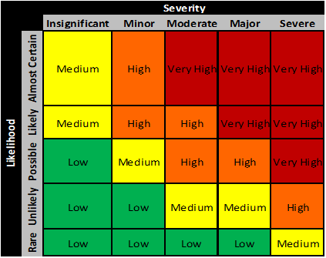

*Table 6.9—1: Risk Management Matrix*

6.9.6. Continuous Improvement

1. Regular Evaluation and Feedback  
    Conduct regular evaluations in IO System to identify areas of improvement. Gather feedback from users and stakeholders to gain insights into system performance and identify paint points.

1. Agile Development and Iterative Enhancements  
    Adopt an agile development methodology to facilitate iterative enhancements and updates to IO System.

1. Continuous Training and Skill Development  
    Provide ongoing training and skill development opportunities for users and system administrators.

1. Stakeholder Engagement  
    Engage stakeholders, including users, in the continuous improvement process. Communicate the benefits of ongoing enhancements to gain stakeholder’s support and participation.

## 6.10. Procurement Plan

6.10.1. Introduction

The Procurement Management Plan plays a critical role in the successful completion of the project. This plan outlines the procurement requirements of the project and how the procurement process will be managed from the development of procurement documentation to the closure of contracts. This plan aims to ensure that all necessary items are procured on time, within budget, and according to the quality standards required for the project.

This plan defines the types of items to be procured, the justification statements and timelines for their procurement, the contract types to be used, the risks associated with procurement management, and how these risks will be mitigated. It also outlines the process for determining costs and evaluating suppliers, including the use of standardized procurement templates and documents.

The plan details how multiple suppliers will be managed if applicable and the contract approval process, decision criteria, and establishment of contract deliverables and deadlines. It explains how procurement and contracts are coordinated with the project scope, budget, and schedule, any constraints pertaining to procurement, and the direction to sellers on baseline requirements such as contract schedules and work breakdown structures (WBSs).

Vendor management is a crucial aspect of the procurement process, and this plan outlines how it will be managed, including the identification of any prequalified sellers if applicable. Finally, the plan defines performance metrics for procurement activities to ensure that the procurement process is monitored and controlled throughout the project's life cycle.

Overall, this Procurement Management Plan is designed to ensure that the project's procurement needs are met efficiently and effectively, with an emphasis on quality, cost, and schedule. It provides a clear and concise roadmap for the procurement process, ensuring that all stakeholders are aligned and informed throughout the process.

6.10.2. Procurement Risks

Procurement is a critical aspect of any project, and it involves the acquisition of goods, services, or works from external sources. Procurement risks are potential issues that can arise during the procurement process, which may negatively impact the project's success. Therefore, it is essential to identify and address these risks proactively to minimize their impact on the project.

The IO System project involves procurement activities that carry inherent risks, which include but are not limited to the following:

Vendor non-performance or non-delivery of goods or services within the project timeline, which may lead to project delays and increased costs.

Changes in the project scope, schedule, or budget, which may affect procurement activities and vendor commitments.

Insufficient documentation, unclear specifications, or incorrect assumptions, leading to misunderstandings between the project team and vendors.

Poor communication or lack of transparency between the project team and vendors, leading to misunderstandings or disputes.

To mitigate these risks, the Procurement Management Plan will include detailed strategies for risk identification, assessment, and mitigation. This plan will be continuously monitored and updated throughout the project's lifecycle to ensure that risks are identified and addressed promptly. Furthermore, we will implement stringent procurement processes and procedures to mitigate the risks associated with procurement management.

6.10.3. Procurement Risk Management

Identification of Procurement Risks

The first step in managing procurement risks is to identify and assess them. For the IO System project, potential procurement risks include:

* + - * Unforeseen increases in the cost of goods or services
      * Delays in the delivery of goods or services
      * Vendor bankruptcy or insolvency
      * Incomplete or poor-quality goods or services
      * Inadequate contract terms and conditions
      * Misalignment of the vendor’s goals with those of the project
      * Inaccurate estimates of costs and timelines
      * Inadequate supplier qualifications

Risk Mitigation Strategies   
 Once procurement risks are identified and assessed, risk mitigation strategies should be developed. For the IO System project, the following risk mitigation strategies will be implemented:

* + - * Conduct thorough market research to identify reliable suppliers with a proven track record of delivering high-quality goods or services.
      * Establish a comprehensive procurement plan that includes clear specifications, delivery schedules, and performance criteria.
      * Conduct a competitive bidding process to ensure that the best value is obtained for the goods or services being procured.
      * Develop clear and enforceable contract terms and conditions that protect the interests of the project.
      * Regularly monitor vendor performance to ensure that goods or services are delivered on time and meet the required quality standards.
      * Establish contingency plans to deal with potential vendor bankruptcy or insolvency.
      * Conduct regular risk assessments throughout the procurement process to identify and address emerging risks.

Assignment of Responsibilities

Responsibilities for managing procurement risks should be clearly assigned to specific individuals or teams. For the IO System project, the procurement manager will be responsible for identifying and assessing procurement risks, developing risk mitigation strategies, and monitoring risk throughout the procurement process.

In addition, the project manager and project team will be responsible for providing input and feedback on procurement risk management strategies.

Communication and Reporting

Effective communication and reporting are essential for successful procurement risk management. Regular status updates on procurement risks and risk mitigation activities will be provided to the project manager, project team, and senior management.

In addition, a communication plan will be developed to ensure that all stakeholders are kept informed of any changes or developments in procurement risk management activities.

Continuous Improvement

Procurement risk management should be an ongoing process of continuous improvement. Lessons learned from procurement risks and risk management activities will be documented and shared with the project team to improve future procurement planning and execution.

Regular reviews of procurement risk management activities will also be conducted to identify areas for improvement.

6.10.4. Cost Determination

In the IO System project, cost determination will be a crucial factor in the procurement process. To ensure the selection of the most competent and cost-effective suppliers, the group will use a complete cost determination process. The cost determination process will comprise gathering quotations, proposals, or bids from possible vendors in response to a Request for Proposal (RFP).

The group will analyze all costs associated with the procurement process, including acquisition, delivery, installation, and maintenance costs. The team will also assess any potential cost overruns and identify ways to mitigate them. The project team will prioritize cost as one of the key decision criteria to ensure transparency and fairness in the selection process.

Several stakeholders, including procurement managers, and project managers will be involved in the cost determination process. These stakeholders will collaborate to ensure that all costs are precisely assessed, and the procurement budget is constantly monitored.

To streamline the cost determination process, the project team will utilize standardized procurement templates and documents. This will help ensure that all cost calculations are consistent and accurate across all procurement activities. Additionally, the project team will establish performance metrics for procurement activities to assess the effectiveness of the cost determination process.

Overall, the cost determination section of the procurement management plan will play a crucial role in ensuring the successful completion of the Dispatch Directory System project within budget constraints.

6.10.5. Procurement Constraints

The following constraints must be considered as part of the Dispatch Directory System project’s procurement management process:

**Schedule constraints:** The project has a strict deadline, and procurement activities must be completed in a timely manner to ensure that the project stays on track. Any delays in procurement activities could impact on the project's overall timeline and delay its completion.

**Budget constraints:** The project has a set budget that must be adhered to during the procurement process. Procurement activities must be planned and conducted in a cost-effective manner to ensure that the project stays within the budget.

**Technology constraints:** The IO System project has specific technological requirements that must be considered during the procurement process. Vendors must have the necessary technical capabilities and expertise to provide the required products and services.

**Vendor selection constraints:** The procurement process for the Dispatch Directory System project must adhere to the organization's vendor selection policies and procedures. Vendors must meet specific criteria, such as past performance and financial stability, to be considered for the project.

**Buyer/seller relationship constraints:** The IO System project has specific requirements for the buyer/seller relationship, including communication protocols, documentation, and reporting. These constraints must be considered throughout the procurement process to ensure that the project's requirements are met.

**Resource constraints:** The procurement process must consider the availability of internal resources, such as personnel, to ensure that procurement activities can be completed efficiently and effectively.

These constraints must be considered throughout the procurement process to ensure that the IO System project's requirements are met within the project's timeline and budget constraints.

6.10.6. Contract Approval Process

The contract approval process for the Dispatch Directory System project will involve a formal and structured approach to ensure that all contracts are approved in a timely and efficient manner. The process will be in accordance with the policies and procedures of the organization and will include the following steps:

Contract Initiation: The Project Manager will initiate the contract process by submitting a request for procurement to the Procurement Officer through the Workday.

Contract Planning: The Procurement Officer will develop a procurement plan that will identify the type of contract to be used, the evaluation criteria, and the timelines for procurement activities.

Contract Development: Once the procurement plan has been approved, the Procurement Officer will develop the contract documents, including the Statement of Work (SOW), terms and conditions, and pricing schedule.

Contract Review: The contract documents will be reviewed by the legal department to ensure that they are following all applicable laws and regulations.

Contract Approval: The contract documents will be submitted to the Contract Review Committee for approval. The Committee will evaluate the contract documents and make a recommendation to the Project Manager.

Contract Execution: Once the contract has been approved, the Procurement Officer will execute the contract and issue a purchase order during the Workday.

Contract Monitoring: The Project Manager will monitor the performance of the vendor to ensure that they are meeting the terms of the contract. The Procurement Officer will also monitor the contract to ensure that all deliverables are met and that payments are made in accordance with the terms of the contract.

The Contract Review Committee will consist of representatives from the Project Management team, the Procurement Officer, and the Legal Department. The Committee will evaluate the contracts based on the evaluation criteria identified in the procurement plan. The Committee will consider factors such as price, quality, delivery, and vendor experience.

The contract approval process will ensure that all contracts are evaluated objectively and that the best value is obtained for the organization. The process will also ensure that contracts are executed in accordance with all applicable laws and regulations.

6.10.7. Decision Criteria

For the IO System project, the following decision criteria will be used by the contract review board:

**Technical Capability:** The vendor must be able to demonstrate that they have the technical skills and capabilities to successfully complete the project. This includes having experience in similar projects and expertise in relevant technologies.

**Price:** The price of the vendor's proposed solution will be a factor in the decision making process. The vendor's pricing should be competitive and reasonable based on market research and other proposals received.

**Schedule:** The vendor must demonstrate that they can meet the project timeline and deliverables, including key milestones and completion dates.

**Quality:** The vendor must have a proven track record of delivering high-quality solutions and services. This includes references and testimonials from previous clients.

**Risk Management:** The vendor must demonstrate a solid understanding of potential risks and have plans in place to mitigate them. This includes identifying potential risks related to procurement, as well as project risks.

**Sustainability:** The vendor's proposed solution should consider environmental, social, and economic sustainability factors, such as the use of eco-friendly materials or supporting local communities.

**Compliance:** The vendor must comply with all legal, regulatory, and contractual requirements, including intellectual property rights, data privacy, and security.

The contract review board will evaluate all proposals based on these criteria and select the vendor that best meets the project's needs and objectives.

6.10.8. Performance Metrics for Procurement Activities

For the IO System project, the following performance metrics will be used for procurement activities:

* + - 1. Vendor Performance Rating:   
         a. This metric can be computed by collecting data on a vendor's performance over a specific period. This data can be gathered from various sources such as internal audits, feedback from project team members, or other performance evaluation methods.   
         b. The rating can be determined by assigning scores to different criteria such as on time delivery, quality of goods or services, responsiveness, and communication. The total score can be averaged and converted to a rating scale such as 1 to 5, with 5 being the highest rating.
      2. Procurement Cycle Time:   
         a. This metric measures the time it takes to complete the procurement process from the initial request to the final delivery of goods or services.   
         b. The computation can be done by calculating the total number of days between each procurement stage (e.g., requisition approval, vendor selection, contract negotiation, delivery) and adding them up. The total number of days can then be divided by the total number of procurement activities to get the average procurement cycle time.
      3. Cost Variance:   
         a. This metric compares the actual procurement costs to the planned costs. The computation can be done by subtracting the planned costs from the actual costs and dividing the result by the planned costs.   
         b. This will give the percentage variance between the actual and planned costs. A positive variance indicates that the procurement costs were lower than planned while a negative variance indicates that the procurement costs were higher than planned.
      4. Purchase Order Accuracy:   
         a. This metric measures the accuracy of purchase orders by comparing the actual goods or services received to the specifications outlined in the purchase order.   
         b.The computation can be done by dividing the number of accurate purchase orders by the total number of purchase orders issued. The result can be expressed as a percentage.

## 6.11. Implementation Plan

6.11.1. Executive Summary

The Dispatch Directory System project is nearing completion, and as part of the project closeout, a transition out plan has been developed to ensure a smooth handover of the system to its new owners. The purpose of this plan is to provide a high-level overview of the transition process, including the history of the contract, the current state of the system, and the planned transition to the new owners.

The Dispatch Directory System was developed by our organization in collaboration with the client to improve their dispatch operations. The system has been in use for the past year and has successfully achieved the project objectives. As per the contract agreement, the system is now transitioning to the client's ownership.

The current state of the system is stable and operational. All required functionalities have been tested and validated, and user training has been completed. As we transition out, we aim to ensure that the client is equipped with all necessary documentation and support to manage and maintain the system effectively.

The new owners will receive all project deliverables, including technical documentation, user manuals, and source code, to ensure they have a comprehensive understanding of the system. We will also provide knowledge transfer sessions to the new owners, covering system operations, maintenance, and troubleshooting.

The transition out plan for the project includes a detailed timeline with a focus on a smooth and successful handover to the new contractor. The execution phase of the transition plan involves user training and go-live, which will take place at the end of August 2023. The closeout phase of the plan involves several key activities, including documenting lessons learned, updating files and records, gaining formal acceptance, archiving files and documents, and holding a project closeout meeting. These activities will take place throughout September 2023, with the project closeout meeting scheduled for the end of the month. Throughout the transition, the transition team will work closely together to ensure a smooth handover and minimize any disruptions to the project's operations. The team will consist of various roles, including the Transition Project Manager, Technical Lead, Subject Matter Experts, Quality Assurance Lead, and Project Team Members. By following this transition plan and timeline, the project team aims to ensure a successful and seamless handover to the new contractor while maintaining the quality of the project's deliverables.

Overall, the transition out plan aims to ensure that the client receives a fully operational and sustainable system, and that our organization completes the project on a positive note.

6.11.2. Transition Approach

**Overall Approach:**

The approach for the Transition Out plan for the Dispatch Directory System Project will be a phased transition approach since there is a need for continuity and minimal disruption to ongoing operations. This approach allows for a gradual and systematic transfer of knowledge, resources, and responsibility to the new team, minimizing the risk of downtime and service interruption.

The transition approach will include the following steps:

1. Communication Plan: The communication plan will ensure that all stakeholders are

aware of the transition plan, timelines, and expectations for the transition.

1. Transition Planning: The transition plan will be developed in coordination with the CREST team, and it will include a detailed timeline of all activities that need to be completed during the transition.

1. Knowledge Transfer: Knowledge transfer will occur through various means, such as documentation, instruction manuals, as-built documents, and formal training classes, to ensure that the CREST team has the necessary skills and knowledge to support the system.

1. Staffing: During the transition, the project team will scale down their staff to a

minimum level required to support the knowledge transfer and transition activities.

**Timeline:**

The transition out plan for this project involves a comprehensive schedule of activities that are necessary to successfully transition from the incumbent contractor to the CREST team. The transition plan is broken down into two main phases, execution and closeout.

The execution phase includes user training and go-live events that are scheduled from August 28th to August 31st. The closeout phase involves document lessons learned, update files/records, gain formal acceptance, archive files/documents, and project closeout meeting.

These activities will be conducted from September 1st to September 29th. The timeline provides a detailed schedule for each activity to ensure timely completion of all transition activities. The success of the transition plan will depend on the careful planning and execution of each activity as outlined in the timeline.

**Assumptions:**

The following assumptions will be made for the transition approach:

1. The CREST SME will be available onsite or via online meeting to participate in the transition and receive knowledge transfer.

1. The project team will provide all necessary documentation, training, and instruction

manuals to the CREST SME to facilitate knowledge transfer.

1. TELUS will provide all necessary equipment and software licenses for the CREST team

to support the system.

1. The CREST team will have the necessary skills and knowledge to support the system

after the completion of the transition.

6.11.3. Transition Team Organization

**Roles and Responsibilities:**

1. **Transition Project Manager (TPM):** Overall responsible for the success of the transition. The TPM will manage the transition team, ensure timely completion of transition activities, coordinate with the customer, and ensure compliance with the transition plan.
2. **Developers/Technical Lead (TL):** Responsible for providing technical expertise on the project. The Developers/Technical Lead will work closely with the project team to understand the system and develop a plan for the transition. The TL will also be responsible for coordinating with the new contractor to ensure a smooth transition of technical knowledge and expertise.
3. **Subject Matter Experts (SMEs):** Responsible for providing subject matter expertise on specific areas of the project. The SMEs will work closely with the developers, project team and the CREST team to ensure a smooth transition of knowledge and expertise.
4. **Quality Assurance (QA) Lead:** Responsible for ensuring that all deliverables meet the quality standards set forth in the transition plan. The QA Lead will work closely with the TPM to develop quality metrics and ensure that all transition activities are completed to a high standard.
5. **Project Team Members:** Responsible for providing support with knowledge and expertise on the system. They will work closely with the TPM, developers, SME, and CREST team members to ensure a smooth transition of knowledge and expertise.

|  |  |
| --- | --- |
| Role | Responsibilities |
| Transition Project Manager | Overall responsible for the success of the transition. Manage the transition team, ensure timely completion of transition activities, coordinate with the customer, and ensure compliance with the transition plan. |
| Developers/Technical Lead | Responsible for providing technical expertise on the project. Work closely with the project team to understand the system and develop a plan for the transition. Coordinate with the new contractor to ensure a smooth transition of technical knowledge and expertise. |
| Subject Matter Experts | Responsible for providing subject matter expertise on specific areas of the project. Work closely with the developers, project team, and the CREST team to ensure a smooth transition of knowledge and expertise. |
| Quality Assurance Lead | Responsible for ensuring that all deliverables meet the quality standards set forth in the transition plan. Work closely with the TPM to develop quality metrics and ensure that all transition activities are completed to a high standard. |
| Project Team Members | Responsible for providing support with knowledge and expertise on the system. Work closely with the TPM, developers, SME, and CREST team members to ensure a smooth transition of knowledge and expertise. |

*Table 6.11—1: Roles and Responsibilities*

6.11.4. Workforce Transition

The workforce transition is a critical aspect of the transition out plan for the Dispatch Directory System project. In order to ensure a smooth and efficient transition, it is essential to determine and communicate the workforce plan of time.

As part of the transition team, the Transition Project Manager will work closely with both the incumbent and new contractors as well as the customer to determine the best course of action for the workforce. This may include retaining current staff, transitioning staff to the new contractor, or hiring new staff altogether.

Communication will be key in this process, as the workforce must be informed of any changes in a timely and respectful manner. The Transition Project Manager will work closely with HR and management to ensure that all staff are aware of their options and are provided with the necessary support throughout the transition process.

In addition, any necessary training or re-training will be provided to ensure that the workforce is fully equipped to continue providing high-quality services during and after the transition period. The workforce transition plan will be regularly reviewed and updated as necessary to ensure that the project is successfully completed on time and within budget.

6.11.5. Workforce Execution During Transition

During the transition period of the Dispatch Directory System project, work will still need to be performed they are as follows:

∙ **User Training:** This will involve the development and delivery of training materials to educate users on the new system. The training sessions will likely be held over a period of three days and will involve both classroom and hands-on training.

∙ **Go Live:** This will be the actual launch of the new system. The team will need to ensure that all systems are in place and functioning correctly before the system is made available to users. This will likely involve final system testing and ensuring that all data has been migrated correctly.

∙ **Document Lessons Learned:** This phase will involve documenting the lessons learned during the project. This includes identifying areas where the team performed well, as well as areas where there is room for improvement. The document will be used to help inform future projects and ensure that best practices are adopted moving forward.

∙ **Update Files/Records:** During this phase, the team will be responsible for updating all relevant files and records to reflect the completion of the project. This may involve archiving certain documents or updating contracts and agreements with new information.

∙ **Gain Formal Acceptance:** This phase involves formally gaining acceptance from the customer that the transition has been completed successfully. The team will need to ensure that all deliverables have been met and that the customer is satisfied with the new system.

∙ **Archive Files/Documents:** This phase involves archiving all project-related files and documents. This may include contracts, agreements, project plans, and other relevant materials.

∙ **Project Close Out Meeting:** The final phase of the transition will involve a project close out meeting with all stakeholders. This will be an opportunity to discuss the project as a whole, including any successes or areas for improvement, and to ensure that all outstanding issues have been resolved.

6.11.6. Subcontracts

There are no existing contracts or subcontract agreements related to this project. Therefore, no transition of contracts or related agreements is required.

6.11.7. Property Transition

6.11.7.1. Government Furnished Equipment (GFE)

Since there is no involvement of Government Furnished Equipment (GFE) in the Dispatch Directory System project, this section of the transition plan is not applicable.

6.11.7.2. Incumbent Owned Equipment

It is important to clearly identify the equipment that is owned by the incumbent and will remain with them. If there is any equipment that is needed to support the customer's applications and services, the plan should state whether the new contractor or customer has the option to purchase or use it. The plan should also include a timeline for the transfer of ownership and any necessary documentation, such as bills of sale or transfer of ownership agreements.

In the case of the dispatch directory system project, if TELUS can provide the necessary equipment upon transition, there may not be a need for the project team to transition the equipment to CREST. However, it is still important to clearly identify which equipment is incumbent-owned and which will be provided by TELUS to ensure a smooth transition and avoid any potential conflicts or misunderstandings. The project team should work closely with TELUS and CREST to ensure that all necessary equipment is available and properly transferred.

6.11.7.3. Intellectual Property

During the transition process of the Dispatch Directory System Project, it is important to consider the handling of intellectual property (IP) to ensure a smooth transfer of all relevant documentation, supplier and subcontractor information, service agreements, or original designs or plans. IP generates many legal considerations and may include the completion of non-disclosure agreements (NDAs) between the incumbent and the customer.

The following steps will be taken to ensure proper handling of intellectual property during the transition:

1. Identification of all relevant intellectual property:
   * All intellectual property related to the project will be identified, including but not limited to design documents, patents, trademarks, copyrights, software code, and any proprietary information or trade secrets.

1. Evaluation of contractual agreements:
   * Existing contractual agreements related to intellectual property ownership and transfer will be reviewed and evaluated to ensure compliance during the transition.

1. Negotiation of new agreements:
   * In case of any gaps or inconsistencies in the existing agreements, new agreements will be negotiated between the incumbent, new contractor, and the customer to ensure proper ownership and transfer of all intellectual property.

1. Protection of intellectual property:
   * During the transition period, all intellectual property will be protected through the use of non-disclosure agreements (NDAs) and other legal measures.

1. Transfer of intellectual property:
   * Upon completion of the transition process, all relevant intellectual property will be transferred to the new contractor, the customer, or retained by the incumbent based on the contractual agreements in place.

By following these steps, the Dispatch Directory System Project can ensure a smooth and secure transition of all intellectual property related to the project.

6.11.7.4. User Accounts and Passwords

As part of the transition plan for the Dispatch Directory System project, it is important to address the transition of user accounts and passwords. The following details the steps and considerations for this aspect of the property transition:

1. User Account Inventory
   * To begin, a comprehensive inventory of all user accounts and their associated privileges should be created. This inventory should include both internal and external users, such as system administrators, third-party vendors, and end users. The inventory should also specify which accounts are no longer active or necessary for the system.
2. Password Security
   * It is essential to maintain security throughout the transition process by ensuring that all user passwords are reset or disabled upon transition. This step helps to prevent unauthorized access to the system and its data. Prior to the transition, users should be notified to change their passwords to a temporary password that will be provided to them. During the transition, the new contractor or system owner should then require all users to create new, secure passwords.

1. Account Transition and Disablement
   * Once the inventory and password security measures have been addressed, the next step is to identify which accounts will be transitioned and which accounts will be disabled. The transition plan should specify the individuals responsible for overseeing the transfer of accounts and passwords to ensure a smooth transition.
   * In cases where accounts are to be disabled, the transition plan should detail the process and procedures for disabling accounts, ensuring that the access rights of terminated employees, contractors or third-party vendors are revoked immediately.

1. Table of User Accounts
   * The transition plan should provide a table of all user accounts to be transitioned or disabled. This table should include the username, the associated email address, and the corresponding privileges or access rights. The table should also indicate whether the account will be transitioned or disabled, along with any specific transition instructions.

In summary, the transition of user accounts and passwords is an essential aspect of the property transition plan for the Dispatch Directory System project. By following a comprehensive inventory, password security measures, account transition and disablement procedures, and providing a table of user accounts, a smooth and secure transition can be achieved.

6.11.8. Knowledge Transfer

Documentation/Manuals:

* + - * The project team and senior developer will provide documentation and manuals to the CREST SME.
      * The documentation will include a project overview, system architecture, functional requirements, technical specifications, and other relevant documentation that can help the CREST team better understand the system and how it works.
      * The manuals will provide step-by-step instructions on how to perform specific tasks related to the system.

Training:

* + - * The CREST SME will receive one-on-one training from the project team and senior developer to ensure they fully understand the system and its processes.
      * The CREST SME will also receive access to online training materials and resources that can help them further develop their knowledge and skills related to the system.
      * The CREST SME will be responsible for cascading the information to the CREST staff as they do not have to be trained in an actual class or accommodate scheduled classes due to the fast-paced environment.

As part of the Knowledge Transfer Plan, regular check-ins and meetings will be scheduled between the project team, senior developer, and CREST SME to ensure that the transfer of knowledge is successful and that any questions or issues are addressed in a timely manner. Additionally, any updates or changes to the system will be documented and shared with the CREST team to ensure they have access to the most up-to-date information.

* + 1. Schedule

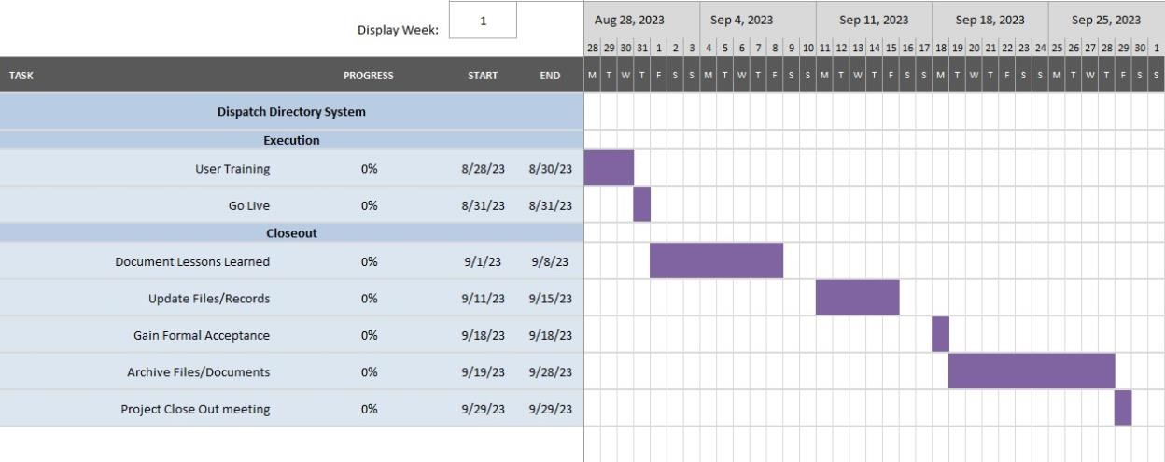

*Figure 6.11—1: Transition Out Plan Schedule*

* + 1. Handover and Acceptance

The handover and acceptance process will begin with the completion of the transition plan, which will include all required documentation and deliverables. The project team will then schedule a formal handover meeting with the project sponsor and other relevant stakeholders to review the transition plan and ensure that all requirements have been met.

During the handover meeting, the project team will present the completed transition plan and all required documentation and deliverables to the project sponsor and other relevant stakeholders. The project sponsor and stakeholders will then review the materials and discuss any outstanding issues or concerns.

Once all issues have been resolved, the project sponsor and stakeholders will sign the formal acceptance document, which will serve as evidence that the handover has been completed successfully. The acceptance document will also include a checklist of all required deliverables and documentation, along with the signatures of all stakeholders who have reviewed and approved the materials.

The handover and acceptance section will also outline the process for resolving any outstanding issues or concerns that may arise after the handover is complete. This may include the use of a formal dispute resolution process or the implementation of corrective actions to address any identified deficiencies.

Overall, the handover and acceptance section of the contract transition out plan will provide a clear and detailed roadmap for completing the handover process and ensuring that all stakeholders are satisfied with the results.

# 7. Sponsor Acceptance

This project acceptance document establishes formal acceptance of all the deliverables for the Dispatch Directory System project. The Dispatch Directory System project has met all the acceptance criteria as defined in the requirements document and project scope statement.

Sponsor Acceptance

Approved by the Project Sponsor:

__________________________________________ Date: March 2023 Mirman Tolentino

Project Manager, Incident Management Division

# 8. List of Tables

Table 1—1: High-level Company Information

Table 3.5—1: Summary Milestone Schedule

Table 6.1—1: Stakeholder Register/Profile

Table 6.1—2: Stakeholder Analysis

Table 6.5—1: Staffing Management Roles and Responsibilities

Table 6.5—2: Staffing Management

Table 6.6—1: Change Control Board

Table 6.6—2: Change Request Roles and Responsibilities

Table 6.6—3: Change Request Process

Table 6.6—4: Change Request Status Description

Table 6.7—1:Communication Management Roles and Responsibilities

Table 6.7—2: Project Team Directory

Table 6.7—3: Communication Matrix

Table 6.7—4: Glossary of Communication Management Terminologies

Table 6.8—1: Quality Management Roles and Responsibilities

Table 6.9—1: Risk Management Matrix

Table 6.9—2: Risk Register

Table 6.11—1: Roles and Responsibilities

# 9. List of Figures

Figure 2.4—1: Estimated Costs

Figure 2.4—2: Cost Benefit Analysis

Figure 3.6—1: Budget Summary

[Figure 6.1—1: Stakeholder Analysis](https://asiapacificcollege-my.sharepoint.com/personal/rrangeles2_student_apc_edu_ph/Documents/Microsoft%20Teams%20Chat%20Files/Consolidated%20Project%20Management%20Plan.docx#_Toc128679381)

Figure 6.3—1: Summary of Budget

[Figure 6.3—2: Summary of Labor Cost Distribution](https://asiapacificcollege-my.sharepoint.com/personal/rrangeles2_student_apc_edu_ph/Documents/Microsoft%20Teams%20Chat%20Files/Consolidated%20Project%20Management%20Plan.docx#_Toc128679383)

[Figure 6.3—3: Summary of Cost Schedule](https://asiapacificcollege-my.sharepoint.com/personal/rrangeles2_student_apc_edu_ph/Documents/Microsoft%20Teams%20Chat%20Files/Consolidated%20Project%20Management%20Plan.docx#_Toc128679384)

Figure 6.5—1: Project Organizational Chart

[Figure 6.6—1: Change Control Process (High Level)](https://asiapacificcollege-my.sharepoint.com/personal/rrangeles2_student_apc_edu_ph/Documents/Microsoft%20Teams%20Chat%20Files/Consolidated%20Project%20Management%20Plan.docx#_Toc128679386)

Figure 6.7—1: Communication Flowchart

Figure 6.11—1: Transition Out Plan Schedule

# 10. Appendices

## 10.1. Project Cost Summary

Approved Budget: ₱ **472,993.69**

|  |  |  |
| --- | --- | --- |
| **Direct Cost** | | |
| Manpower Cost | 9 months | **₱ 238,788.75** |
| Maintenance Cost | Per call | **₱ 15,000.00** |
| Contingency Cost | 9 months | **₱ 114,204.94** |
| **Total Project Cost** |  | **₱ 367,993.69** |
| **Indirect Cost** | | |
| Computers | Once | **₱ 105,000.00** |
| **Total Indirect Cost** |  | **₱ 105,000.00** |

## 10.2. Project Methodology

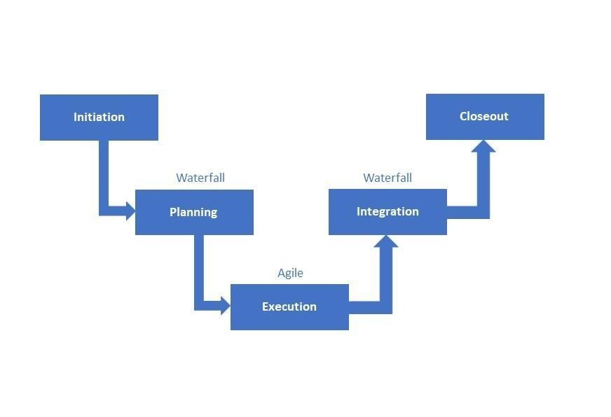

## 10.3. System Requirements Specifications

10.3.1. System Requirements for Development

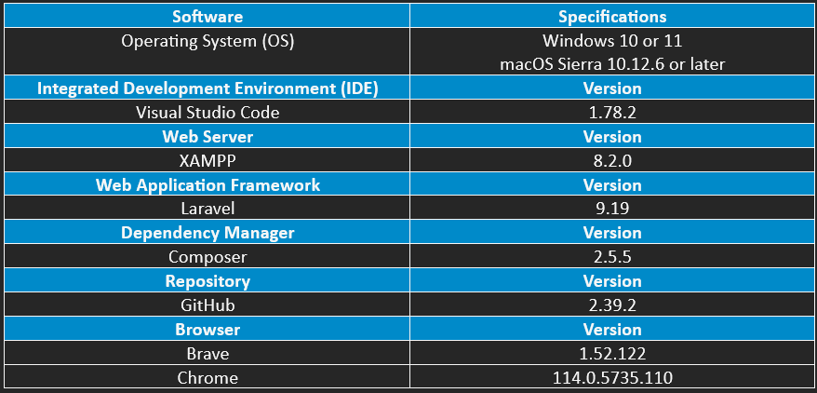

10.3.2. System Requirements for Deployment

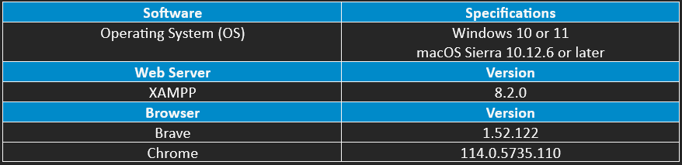

## 10.4. Development Tools Specification

10.4.1. Development Tools Specification

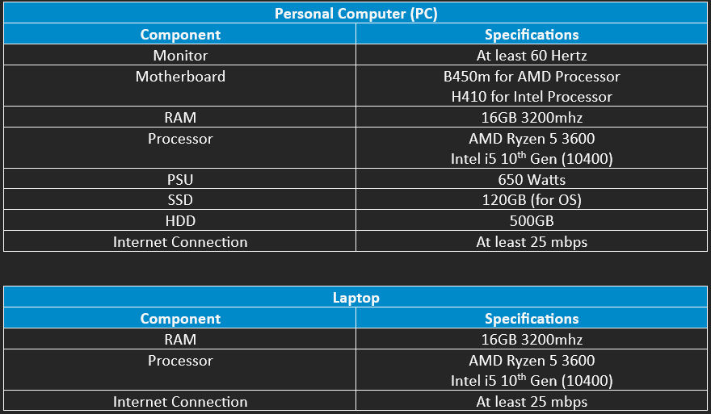

10.4.2. Deployment Tools Specifications

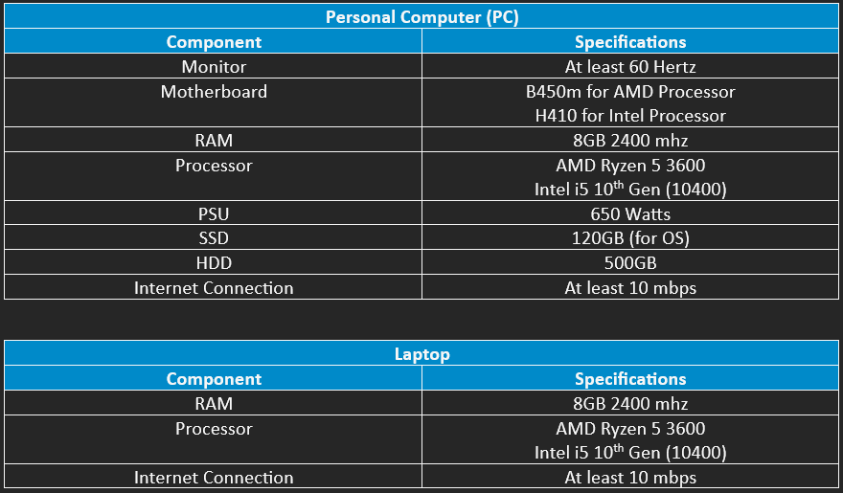

## 10.5. WBS Dictionary

|  |  |  |  |  |
| --- | --- | --- | --- | --- |
| **Level** | **WBS Code** | **Element Name** | **Definition** | **Estimated Duration** |
| 1 | 1 | Ordering System and Inventory System | All work to implement a new Inventory and Ordering System | - |
| **2** | **1.1** | **Project Planning** | **The work for the planning process for the project** | **21 days** |
| 3 | 1.1.1 | Define project scope and objectives | Project Team defines project scope and objectives | 5 days |
| 3 | 1.1.2 | Identify project stakeholders | Project Manager identify and meets with project stakeholders | 4 days |
| 3 | 1.1.3 | Develop project schedule | Project Team develops a project schedule | 5 days |
| 3 | 1.1.4 | Define project budget | Project Manager defines project budget | 5 days |
| 3 | 1.1.5 | Establish project team roles and responsibilities | Project Manager assigns roles and responsibilities to Project Team | 2 days |
| **2** | **1.2** | **Requirements Gathering** | **The work for gathering all requirements for the project** | **20 days** |
| 3 | 1.2.1 | Define system requirements | Project Manager defines system requirements | 4 days |
| 3 | 1.2.2 | Identify inventory system requirements | Project Manager identifies inventory system requirements | 5 days |
| 3 | 1.2.3 | Identify ordering system requirements | Project Manager identifies ordering system requirements | 5 days |
| 3 | 1.2.4 | Define user requirements | Project Team defines user requirements | 3 days |
| 3 | 1.2.5 | Conduct stakeholder interviews | Project team conducts stakeholder interviews | 3 days |
| **2** | **1.3** | **System Design** | **The work for all system design such as diagrams and workflows** | **33 days** |
| 3 | 1.3.1 | Design ordering system | Project Team designs diagrams for ordering system | 6 days |
| 3 | 1.3.2 | Design inventory system | Project Team designs diagrams for inventory system | 7 days |
| 3 | 1.3.3 | Define user interface design | Project Team defines user interface design | 5 days |
| 3 | 1.3.4 | Determine software and hardware requirements | Project Manager determine all software and hardware requirements | 5 days |
| 3 | 1.3.5 | Develop system architecture | Project Manager develops system architecture | 10 days |
| **2** | **1.4** | **System Development** | **All work for developing the IO System** | **29 days** |
| 3 | 1.4.1 | Code ordering system | Project Team codes ordering system | 10 days |
| 3 | 1.4.2 | Code inventory system | Project Team codes inventory system | 10 days |
| 3 | 1.4.3 | Integrate system components | Project Team integrates system components | 4 days |
| 3 | 1.4.4 | Develop test plans | Project Team develops test plans | 3 days |
| 3 | 1.4.5 | Conduct testing | Project Manager conducts testing of the system | 2 days |
| **2** | **1.5** | **System Implementation** | **All work for implementing the IO System** | **10 days** |
| 3 | 1.5.1 | Deploy system in test environment | Project Team deploys IO System in test environment for run through | 5 days |
| 3 | 1.5.2 | Train system users | Project Team trains system users, includes admin users and test customers | 1 day |
| 3 | 1.5.3 | Resolve any issues found during testing | Project Team resolves any issues found in the system while testing | 3 days |
| 3 | 1.5.4 | Deploy system in production environment | Project Team deploys system in production environment, and it is ready to use | 1 day |
| 3 | 1.5.5 | Perform system maintenance and support | Project Team are responsible for maintenance and support if any errors occur | - |
| **2** | **1.6** | **Project Management** | **All work for Project Management in IO System** | **25 days** |
| 3 | 1.6.1 | Monitor and control project progress | Project Team monitors and controls project progress of the IO System | 5 days |
| 3 | 1.6.2 | Manage project risk and issues | Project Manager manages project risk and issues occur | 5 days |
| 3 | 1.6.3 | Communicate project status to stakeholders | Project Manager communicates with the stakeholders for project status and other updates | 5 days |
| 3 | 1.6.4 | Ensure project deliverables meet quality standards | Project Manager ensures project deliverables meets the quality standards | 5 days |
| 3 | 1.6.5 | Obtain project acceptance from stakeholders | Project Team meets with the stakeholders for project acceptance | 5 days |

10.6 Detailed Schedule

10.7 Detailed Cost Estimate

|  |  |  |  |  |  |  |  |  |  |  |  |  |  |  |  |  |  |
| --- | --- | --- | --- | --- | --- | --- | --- | --- | --- | --- | --- | --- | --- | --- | --- | --- | --- |
| **Inventory and Ordering System (IO System)** | | | | | | | | | | | | | | | | | |
| Budget |  | Amount | | | |  | Project Duration (months) | | | |  |  | 9 | | |  |  |
|  |  |  |  |  |  |
| **Project Cost Elements** | | | | | | | | | | | | | | | | | |
| **Manpower Costs Estimates** | | | | | | | | | | | | | | | | | |
| **Role** | |  | **Average Salary (monthly, 5-hour shift)** | | | | | **Total Salary** | | | | **Count** | | **Total Cost (9 months)** | | | |
| Project Manager | |  | **₱ 5,329.35** | | | | | **₱ 47,964.15** | | | | **1** | | **₱ 47,964.15** | | | |
| Project Documentations Manager | |  | **₱ 1,074.00** | | | | | **₱ 6,444.00** | | | | **1** | | **₱ 6,444.00** | | | |
| Scrum Master | |  | **₱ 10,097.75** | | | | | **₱ 30,293.25** | | | | **1** | | **₱ 30,293.25** | | | |
| Scrum Member  Product Owner | |  | **₱ 4,207.40**  **₱ 15,718.35** | | | | | **₱ 12,622.20**  **₱ 141,465.15** | | | | **1**  **1** | | **₱ 12,622.20**  **₱ 141,465.15** | | | |
| **Maintenance** | | | | | | | | | | | | | | | | | |
| Maintenance | |  |  |  |  |  | **₱ 15,000.00** | | | | | |  |  |  |  |  |
|  |  |  |  |  |  |  |  |  |  |
| **Contingency Cost** | | | | | | | | | | | | | | | | | |
| Estimated Contingency Cost | |  | **₱ 12,689.44** | | | |  |  | 9 Months | | | |  | **₱ 114,204.94** | | | |
|  |  |  |  |
| **Indirect Cost** | | | | | | | | | | | | | | | | | |
| Computers | |  | **₱ 35,000.00** | | | |  | **3** | | | |  |  | **₱ 105,000.00** | | | |
|  |  |  |  |
| **Estimated Total Project Cost** | | |  |  |  |  |  |  |  |  |  |  |  | **₱ 472,993.69** | | | |
|  |  |  |  |  |  |  |  |  |  |  |